eyeCAN

Business Plan
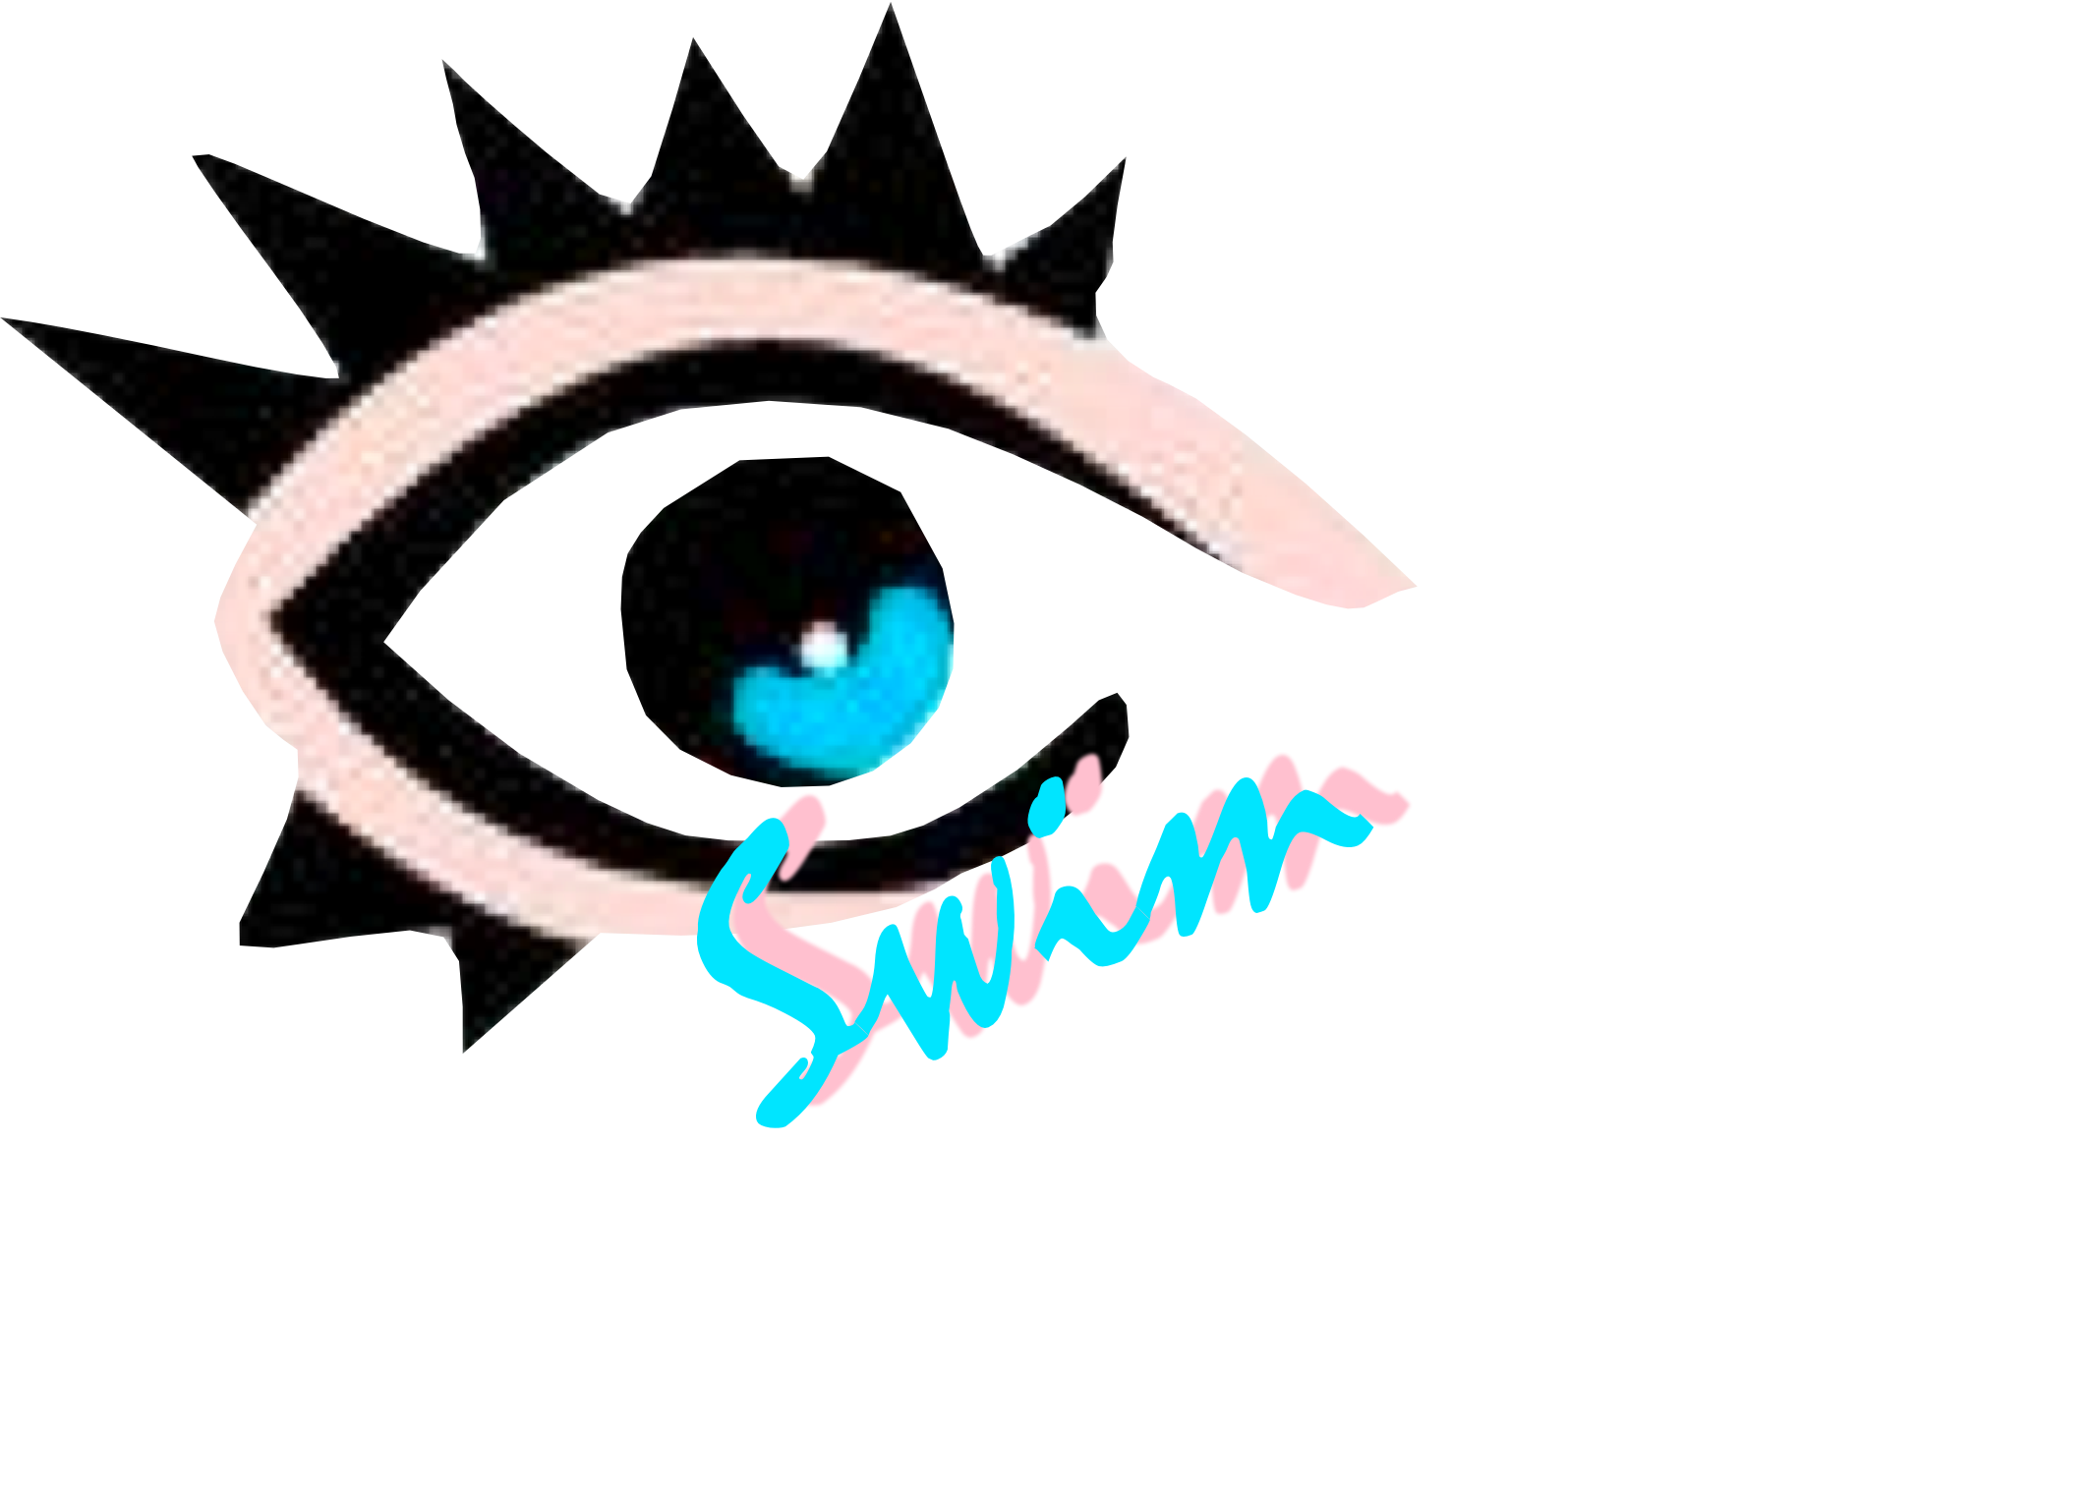

ENPRO 357 Team Members:
Tito Rodriguez
Pedro Lima
Zhenlin Lu
Hernan Canales

Illinois Institute of Technology
3300 S. State
Chicago, Illinois

Table of Contents
I. Table of Contents 2
II. Executive Summary 3
III. Business Description 4
IV. Product 6
V. Market Research 9
VI. Competitive Analysis 11
VII. Marketing Plan 15
VIII. Manufacturing and Operations 17
IX. Key Assumptions 19
X. Financial Plan 20
XI. Bibliography 30

Executive Summary
eyeCan seeks to develop and prototype assistive devices that will enable the visually impaired to exercise independently. Initially, our efforts have been devoted to developing a device that will allow such individuals to swim independently which from a sighted person’s perspective might not be perceived as an issue. From research we have found this not to be the case, for the visually impaired it’s very difficult to swim without causing harm to themselves. With our product eyeSwim, we hope to improve the quality of life for visually impaired individuals by providing them with opportunity to exercise safely. Currently, eyeCan is in the process of researching other activities i.e. running, biking, climbing which may prove to be another opportunity for expanding the business’ focus.

Business Description
Our business’ value proposition is to enable the visually impaired to exercise independently. eyeCan’s business model will primarily rely on its ability to conduct research and development products based on the findings through its research. The products will continuously be improved upon which simultaneously the scope of the business will expand into developing devices that will allow the visually impaired to participate in many other interesting and exciting activities that most people take for granted i.e. weight training, running, biking, climbing with only the assistance of our products. We are in the process of trade marking a conceptual name for each activity where we will use the word “eye” as a prefix to a general activity. Additionally, we have put together some provisional patents pertaining to eyeSwim’s, eyeCan’s first product, which will protect the intellectual property associated to the unique way in which the eyeSwim’s T-connectors are designed. Eventually gaining a full patent for our technology, we believe, will provide eyeCan with the leverage it needs to be competitive.
Mission statement:
“It is the mission of eyeCan to be the leaders in research and development for the design of high quality assistive devices that will enable the visually impaired to exercise independently; by taking into account their safety, health, and life.”
Goals and Objectives:
- To successfully develop an assistive device that will allow visually impaired individuals to swim independently.
- Once successful at marketing and selling the assistive swimming device, eyeSwim, then broaden the scope of the business by expanding into other niches within the visually impaired exercise market potentially with products dubbed: eyeRun, eyeClimb, eyeBike, etc.
- To maintain a standard of high quality with every product developed by ABVIE
- To be both a profitable business while still contributing to an overall social good
Our philosophy at eyeCan is that the motivation behind every development will be to improve the quality of life for our customers. The general need we perceive to not have been fulfilled for our customers is the ability to exercise independently without the fear of being injured. eyeCan is interested in eliminating such risks of injury by developing devices that will mitigate such concerns. Maintaining a standard of high quality for our products is extremely important due to the inability to see, our customers will have to place faith on the integrity of our products. This would be quite difficult to gain such trust with low quality devices.
According to the World Health Organizations (WHO) statistics, there are 161 million people in the world who are living with a disabling visual impairment; and of these roughly 20% are completely blind. According to the National Federation for the Blind and US Census data, it is estimated that there will be a 100% growth in this demographic over the next 20 years. With respect to the United States, there is approximately 15 million visually impaired and 1.5 million completely blind individuals, and because of their visual impairments it is estimated that less than 1% of this demographic participates in regular physical activity. With respect to physical activity, even fewer individuals swim as a result of not feeling safe and secure while doing so. Our products will target individuals, companies, and facilities with vested interests in the Visually Impaired community.
Our market growth potential according to a research there is a 50% increase in blind persons in the US and extrapolate that for international from 1990 to 2020 (38million to 76 million). The projected numbers of seniors who will be blind for year 2015 are approximately 1.6 million and for year 2030 there would be 2.4 blind seniors. There is on average 54,000 per year who will be blind and can be potential customers. After this research we can see that the industry is very attractive since the number of potential customers can double in the next years and this is very positive for our business because we can take advantage by creating new products and satisfying every need of every new customer.

Product
Our mission is to create a line of products that enable visually impaired people to enjoy recreational activities without assistance. The first product eyeCan is developing is called eyeSwim. eyeSwim is static device which will be installed into swimming pools to allow visually impaired individuals to swim freely without human or active assistance.
eyeSwim works using physical “tapers” attached to tensioned lines that stick into the lane notifying swimmers through tactile sensations when they drift to either side. By using wider and vastly different designs for the tapers at the ends compared to those along the sides of the pool, swimmers can tell when they are approaching the end of the lane and prepare to turn around or stop. The device is also adjustable as tapers can be spaced however the pool operator wants based on feedback from swimmers. It is also robust, the side tapers are flexible and the end tapers are solid but soft and attached with a spring-like connection to return back to their effective position after swimmers move them by swimming through.
Figure 1 shows eyeSwim Version VI during a pool test on Sunday, March 08, 2008. The swimmer in the photo is Mazen Istanbouli, a DePaul University Political Science Professor and a blind swimmer who has participated in ABVIA pool tests since fall 2007.
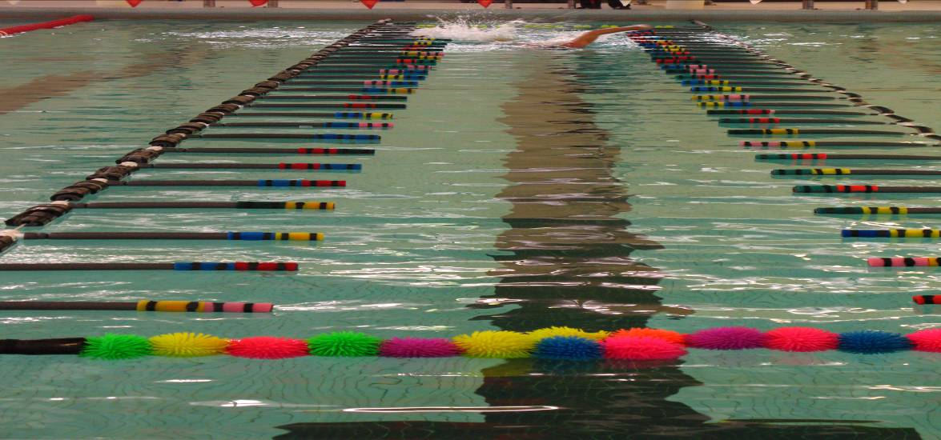
SIDE TAPPERS
END TAPPERS
Lane Line
Figure 1 shows eyeSwim Version VI illustrating key eyeSwim components (Side Tappers, End Tappers and Lane Lines) used by blind swimmers to establish lane position and execute corrective maneuvers.
Figure 2 shows details of the side tapper, end tapper, lane line and the unique design of the ‘T’-Connector.
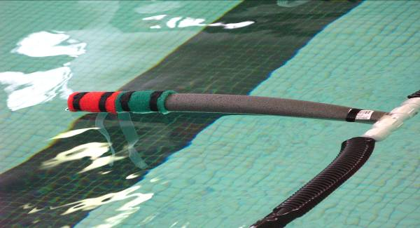  SIDE TAPPER  ICICLES  (a) | 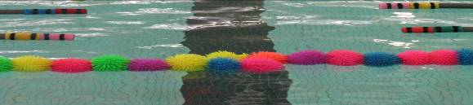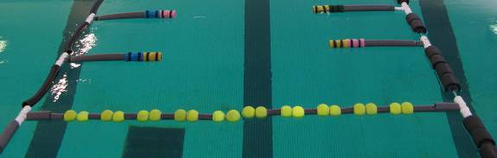  END TAPPER I  END TAPPER II  (b)
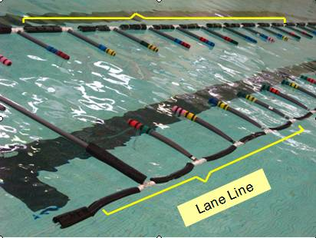  (c) | ‘  T-Connector  (d)

Figure 2 (a) Shows the side tapper designed to guide the swimmer toward the center of the lane. The icicles in the side tapper help guide the swimmer toward the lane center while swimming the breast stroke. (b) The end tapper alerts the swimmer that he/she is a few feet from the end of the lane. (c) The lane lines indicate lane boundaries and guide the swimmer to return to the center of the lane. (d) The ‘T’ Connector, the most crucial component of eyeSwim, is designed to make it easy and quick to assemble the entire device, change positions or types of side and end tappers along the lane lines and also to change the number of side tappers or end tappers according to the preferences of blind swimmers. Swimmers have quite different body sizes so that the preferred position of end tappers varies not only with personal preference but with length of arms and legs. The ‘T’ Connector can slide along the lane line when uncapped and locks into position when capped. Extra ‘T’ Connectors enable the installation of more side tappers or end tappers according to the preferences of the swimmer. The ‘T’ connector also connects the side tappers and end tappers to the lane lines and is designed to make the attachment and removal of the side or end tappers very quick and simple.
eyeSwim has many benefits for visually impaired users, since the need for human tapers is removed by using the eyeSwim visually impaired swimmers gain independence while swimming since they no longer need end-lane assistants to help keep them from running into a wall. The cost of paying professional tapers can also be very expensive and is no longer necessary when using this device. Visually impaired swimmers can now swim without pain because they no longer need to swim against the hard plastic lane lines to keep them swimming in a straight line. The visually impaired swimmers can now feel safe and not fear swimming because they will be able to keep track of where they are in the pool. Most importantly, more visually impaired individuals will have the opportunity to participate in this excellent exercise and gain a sense of pride and feeling of accomplishment as they learn a new and important skill.
In addition to our products, eyeCan plans to develop a website which will provide our customers with installation information, instructional videos on how to train the visually impaired on how to use the device, provide users with FAQ’s as well as a question link so any other questions they may have can be answered. eyeCan believes this is on step in the right directions to continue relationships with customers as well as gain necessary feedback which will aid the future improvements to eyeSwim as well as any other future products.

Market Research
Visually Impaired
Our research has provided us with a significant amount of information regarding the target market eyeCan wishes to serve, and that being the blind and visually impaired. We have found that visually impaired individuals, including blind individuals as well, account for fifteen million in North America alone according some statistics from the World Health Organization. This demographic is expected to almost double in size within the next twenty years. Currently, there is an increase of about 1 visually impaired person every minute and 7 more blind people every hour.
With respect to exponential growth within this demographic, our research has yet to have shown any companies and/or product which intend to serve this market directly with respect to enabling them to exercise. It is estimated that less than 1% of blind people exercise. We have discovered that the lack of exercise can be contributed to the fact that the visually impaired do not feel any sense of security or safety from harm while participating in physical activity. This can inevitably become detrimental to one’s health. According to the World Heart Federation, physical inactivity can double the chance of developing heart disease while increasing the risk of diabetes and high blood pressure.

Swimming Pools and Industry
Our research pertaining to the swimming pool industry, we have found there to be roughly 8.6 million swimming pools in the United States. On average, an impressive $3 Billion is spent per year on equipment and maintenance for those pools. These figures are based on GNP within the industry as well as annual expenditures. The swimming pool industry, due to its market maturity, has very high barriers to entry.

Assistive Device Industry:
Our research on the assistive devices industry has shown that revenues for products and services for the year 2007, were upwards of $3.2 billion dollars. These figures are an increase of about 150% compared to the figures from reports in 2006. We estimate that the North America portion of this market is 15% or $450 million per year. The revenues experienced from this industry indicate that the visually impaired and the organizations that support them are spending significant amounts of money on assistive devices alone.

Competitive Analysis
Our research has provided us with no information regarding direct competition. Currently, there are few if any products or services which specifically help blind people to exercise. It is further estimated that less than 1% of visually impaired individuals exercise; as a result from not feeling safe or secure while doing so. For example, few if any pools specifically accommodate blind swimmers and we cannot find any manufacturers producing products to aid blind swimmers. However, it is very clear from our interviews with blind people that swimming is a form of exercise that they enjoy or will enjoy if more opportunities to swim are made available to them.
Current Potential Competition:
John M. Komer has a patent on a lane marker for the visually impaired. The device includes a perforated tube that extends the length of a swimming pool. The perforated tube is in fluid communication with a source of compressed gas, such as an air compressor. The air compressor delivers pressurized air to the tube. The pressurized air escapes through the perforations forming a line of bubbles along the swimming lane. The blind swimmer can feel these bubbles and determine his position in the swimming lane.

Future Potential Competiton:
Looking toward the future, however, we perceive there to be some possible competition from the Assistive Devices Industry and/or the Swimming industry. In both industries there are medium to large sized companies that possess the ability to easily enter into this market. Here are some companies we have paid some mind:

Assistive Device  Industry | Products | Potential Growth | Location
LS&S | Magnisight, Reinecker, Coil, Schweizer, Walters, Beecher, NoIR, etc NO Similar Device | Increase(Constantly expanding product offering) | 1808-G Janke Dr. Northbrook, IL 60062
Independent  Living Aids | Daily Living Aids for visually impaired or blind NO Similar Device | Increasing(ship to all 50 states and throughout the world, many products are developed and produced outside of the United States) | 200 Robbins Lane Jericho, NY 11753
MaxiAids | Over 4000 products for daily living aids (like talking watching, folding canes, magnifiers, talking calculators, braille watches, amplification systems, etc) No Similar Device | Increasing (world's leading provider for adaptive products) | 42 Executive Blvd Farmingdale, NY 11735

Swimming Industry | Products | Potential Growth | Location
Kiefer | Swimsuits; Swim Caps; Shorts; Parkas; T-shirts; Bags; Sweats (pants and shirts); Warm-ups; Stadium Chairs; Equipment Bags; Stretch Cords; Racing Lanes; VASA Swim Trainers; Deck Exercise Mats; Fins; Starting Systems; Kickboards; Pull Buoys; Paddles; | Increasing (cooperate with Speedo, TYR, or Nike ) | 1700 Kiefer Drive,  Zion, Illinois 60099
Swim2000 | Swimsuits; Equipment; Swimwear; Bags; Goggles; Lifeguard/Guard | Increasing (good customer service-international Shipping, quick shipping, the low price) | 4137 S. Maryland  Las Vegas, NV 89119
Speedo | Aqualab; Watershorts: Tees; Flipturns; Triathion; Footwear; Lifeguard; Goggles; Swim Caps; Training gear; bags; Aquatic fitness; Electronics | Increasing(big brand name) | 6040 Bandini Blvd.  Los Angeles, CA 90040

Competitive Advantage:
We have filed a provisional patent application for eyeSwim based primarily on the uniqueness of the connector device. However, this is likely to be a very small niche market for some time due to the current small number of blind swimmers and the need to provide pool access as well as install and maintain the eyeSwim device. Until eyeSwim receives wide exposure and acceptance, we do not expect serious competition.
Based on the patent research performed for the last two semesters, we have yet to find an assistive device which enables blind and visually impaired swim safely. eyeSwim with its specific design configuration is a new device and it satisfies the three main criteria that determine the device’s patentability: novelty, inventive step and industrial applicability.
The T-Connector and the Lane Line Tapers are manufactured using other starting materials such as the caps (T-Connector) and the foam tubes (Side Tapper). (Refer to Figure 2) However, the innovative part is manifested in the ways these elements are put together to address the problem of blind or visually impaired swimmers. The idea of connecting the different parts of the connector in a way that allows it to slide along the lane line and be locked at a desired position is an innovative one and it satisfies the invention step requirement. The tubes used for the lane tappers are connected in a way that allows them to be adjusted to the desired length. This characteristic is also an innovative way of designing a Side Tapper and it satisfies the Inventive Step Criteria.
The Industrial Applicability of eyeSwim is determined by its utility value. eyeSwim is designed to address the problem blind and visually impaired swimmers face while swimming. It aims at increasing their independency, consistency and most importantly their safety in the swimming pool.
As mentioned previously, the majority of the blind and visually impaired individuals don’t swim because of their fear of losing direction in the pool while swimming, in addition to the possibility that they can collide into the wall once they reach the end of the pool which will most likely end up with some form of bodily harm being inflicted on the individual. With the assitance of eyeSwim, the blind and visually impaired swimmer will have a constant awareness of his/her position relative to the side lane lines as a consequence of the constant interaction with the Side Tappers. The swimmer will also get a signal once they hit the End Lane Tappers, alerting him or her of the nearness of the end wall.
eyeSwim device is an innovative approach to solving the problem of blind and visually impaired swimmers. The changes that have been made to its design, and especially the integration of the T-Connectors, have enhanced its performance tremendously. At this stage, it is very crucial to file a provisional application with the United State Patent and Trademark Office, protect the rights of owning the idea, and give credits to the individuals who developed it. This provisional application allows for a simplified filing process at a lower cost, and establishes an application filing date with eyeSwim. During the 12 months period of this application, changes could be made to the design of eyeSwim to improve its performance.

Marketing Plan
Our key marketing strategy is to partner with companies already servicing the Swimming Industry and the Assistive Devices Industry. It is the intention of eyeCan to continue performing the R/D function of the business. While still generate publicity within the blind community through our partnership with the Chicago Light House for the Blind.
Customer Strategy:
Our target market is visually impaired individuals that currently exercise. The motive behind doing so is the hope that success stories will be created through the use of our products. This possible can create some positive “word of mouth” publicity that will circulate the visually impaired community making it easier to better serve this market.
Partnering Strategy:
Currently, there are several assistive devices serving to the visually impaired demographic, however none claim to enable the visually impaired to exercise. Such devices provide a similar benefit to the target market as we wish to provide. Although it is eyeCan’s vision to serve them in a way that it has yet to be served, we are “enabling the visually impaired to exercise independently.” We believe that with positive feedback from our customers in addition to our strong value proposition; eyeCan can gain the attention of some larger companies that might pursue a partnership with us.
We believe that swimming companies and/or assistive device companies will be interested in partnering on eyeSwim for the public relations value and that assistive devices companies will see a chance to sell more products through their distribution systems and to their existing customers if they offer eyeSwim. We expect to have a swimming products partner company manufacture, install and service the product as those functions fit better with their operations than with our R/D functions. Our partnership will enable eyeCan to focus primarily on the R&D and Market Research functions of the business. Once an actual partnership is attained, students from Ipro teams will be the primary research and developers.
All sales and marketing functions will be handled by students from the teams as well. The students will utilize the marketing channels provided to them by IIT and/or our partners, as well as our continued relationship with the Chicago lighthouse for the blind. However, that is unless our partnership arrangement handles this function as well. These functions are essential not to the success of eyeSwim but to the success of eyeCan as a business. Therefore, our best case scenario would be to outsource this funcition to our partner or outside contractor once some revenue is generated.

Manufacturing and Operations
The manufacturing and operations functions for eyeCan will initially be carried out by IPRO teams which is also dependant on whether or not this EnPRO is chosen to be continued onto further other semesters. Currently, the amount of time it takes to manufacture a single device is roughly fifty hours, which at minimum wage will cost about $350 in labor alone. Since eyeCan currently does not have in its possession a product ready for market and no revenue generation; paying someone to manufacture eyeSwim is highly infeasible. This is why initially all manufacturing and R&D functions , as stated prior, will be Team members will continue to manufacture and design all further prototypes.
With regard to the manufacturing function, all raw materials will be purchased by the IPRO office in addition to contributions from grant monies. Most if not all the labor will be a contribution of students time as a requirement of being part of the EnPRO/IPRO. However, in the near future once we have developed a product that is ready for market a next step will be to contact companies such as Kiefer and Speedo to attempt to work out some sort of partnership deal where they handle the manufacturing side of our business while we focus on the R&D aspect of the business.
Once eyeCan attains a partner whom will carry out the manufacturing function of the business; the Enpro/Ipro team can focus on the development aspect which is more pertinent to the operations side of the business. The design cycle will be utilized as the main operation of the business. Currently, the Ipro team possesses a unique design cycle which has been used and improved upon for the past three semesters.
eyeCan’s Design Cycle
The ABVIA team has been implementing at least two design cycles every semester since the summer term of 07. Each design cycle includes:
- Brainstorm: Identify changes and problems with eyeSwim and other future products.
- Design: research, redesign, sketch, prototype and purchase materials
- Manufacture: Schedule production and build the improved versions of our products.
- Test: Recruit at least 3-6 visually impaired individuals that will participate in testing of our products, implement the design, conduct tests with appropriate IRB approval and consent forms, interview swimmers after they’ve used our devices for user-feedback, also we will document the tests by questioning participants as well as photographing and videotaping their interactions with the devices.
- Re-evaluate: Discuss all design changes that worked, list all changes that need to be made and document appropriately.
- Provide feed back and appreciation to everyone involved during the cycle and
- Prepare for the next design cycle.
Each cycle takes 4-7 weeks; the team makes a detailed plan at the beginning of each test cycle and completes two cycles per semester.

Key Assumptions
Market
- 8.6 Million Of swimming pools in US, Target 1% of swimming pools
- Target 1% of swimming pools. (According to the data from World Health Organization, we know the blind or visually impaired population is approximately 10 million in the United States. Comparing to the entire population in the United States which is 301,139,947, it stands for 3.32%. The number of swimming pools owned by blind or visually impaired must be less than 3.32% with respect to the ratio of blind or visually impaired population. Therefore, we assume to target 1%)

Product
- Manufacturing Costs $600
- Labor Costs (50 hours at $12)
- Price 2,000 ( for having an average of 30% margin for the first 3 years) (price for
- 600-800 for 1 normal lane dividors)

Start-up Expenses
- 1 part-time contractor (If we hire a full time employee, we need to pay 40hrs*$12=$480 per week, plus bonus which will be almost $500 per week, $2,000 per month. If we hire a part-time contractor, we just need to pay the time they work, not like part-time employee.)
- $5,000 won from Getch Social Entrepreneur Competition as back-up
- Manufacturing cost is $600
- Labor cost is $600
- Telephone fee is $50 for one year contract by T-Mobile, providing 800 minus in the day time and free from nine pm to seven am.
- Provisional patent application fee is around $1,200
- Total Start-up expense is around $2,450
- We assume that the initial investment is $2,500

Financial
- 1st year .008%(6 out of 86,000) target market (1 unit every 2 months)
- 2nd year .01% (9 out of 86,000) target market ( 3 units every 4 months) 50% increase in sales
- 3rd year .015 %(12 out of 86,000) target market ( 1 unit per month) 33% increase in sales

Financial Plan
For the financials we are considering three different business scenarios that could actually happen in this project. The first scenario is to keep IIT students working on this project, it could be as IPRO teams or as a student organization of students who want to gain experience running a business or who want to do a social good for the community. Students will manufacture and sell the swimming device. There are 8.6 Million of swimming pools and our target market is 1% of this pools. The price for our swimming device is going to be $2,000. The labor costs for each device are $600 because it takes 50 labor hours to build a device and we are going to pay $12 per labor hour. We are considering hiring one contractor to manufacture the device because students are not going to gain to much knowledge and experience manufacturing the device, and with the price we are going to charge our business has the capacity to hire this contractor. The total labor hours and labor costs are under exhibit 1. The costs for the manufacturing material are $600. Under this scenario we expect to sell 6 devices the first year. We expect an increase of 50% for the second year, and for the third year we expect to sell one device per month (sales forecast exhibit 2). The net income for the first three years is presented in exhibit 3. For the first year we expect to build the device in one month and to sell it the following month. Just for the first month running the business we are going to manufacture two devices because maybe customers are going to want to try the device for several time before buying it so we are going to have one additional device for that situation. We need an initial investment of $2,400 in order to build the first two devices. After we sell the first device we do not need any more investments because we the revenues we have the capacity to run the business through the whole year as you can see in exhibit 4.

EXIHIBIT 1A
Labor Costs
Year | 1 | 2 | 3
Labor hours | 350 | 450 | 600
Total Weeks | 7.5 | 11 | 15
Cost per hour | $12 | $12 | $12
Total Cost | $4,200 | $5,400 | $7,200

EXHIBIT 2A
Sales Forecast (First Three Years)
Year | 0 | 1 | 2 | 3
Sales (Units) |  | 6 | 9 | 12
Price |  | $2,000 | $2,000 | $2000
Total Revenues |  | $12,000 | $18,000 | $24,000

EXHIBIT 3 A
Income Statement for the first three years

 | Year 1 | Year 2 | Year 3 | Total
Revenues
Gross Sales | $ 12,000.00 | $ 18,000.00 | $ 24,000.00 | 54,000.00
Less Returns and Allowances
Net Sales | $ 12,000.00 | $ 18,000.00 | $ 24,000.00 | 54,000.00
Costs of Goods Sold
Manufacturing Material | $ 4,200.00 | $ 5,400.00 | $ 7,200.00 | 16,800.00
Direct Labor | $ 4,200.00 | $ 5,400.00 | $ 7,200.00 | 16,800.00
Indirect Expenses
Total Cost of Goods Sold | $ 8,400.00 | $ 10,800.00 | $ 14,400.00 | 33,600.00
Gross Profit/Margin | $ 3,600.00 | $ 7,200.00 | $ 9,600.00 | 20,400.00
Administrative Costs
Advertising | 0 | 0 | 0
Telephone | $ 600.00 | $ 600.00 | $ 600.00 | 1,800.00
Travel | $ 1,800.00 | $ 2,700.00 | $ 3,600.00 | 8,100.00
Patent and Trademark
Office Expense
Total Expenses | $ 2,400.00 | $ 3,300.00 | $ 4,200.00 | 9,900.00
Net Operating Income | $ 1,200.00 | $ 3,900.00 | $ 5,400.00 | 10,500.00

EXHIBIT 4 A
Cash Flow for the first three years

 | Year 1 | Year 2 | Year 3 | Total
Cash receipts
Sales | $ 12,000.00 | $ 18,000.00 | $ 24,000.00 | 54,000.00
Less Returns and Allowances
Total Cash Receipts | $ 12,000.00 | $ 18,000.00 | $ 24,000.00 | 54,000.00
Cash paid out
Manufacturing Material | $ 4,200.00 | $ 5,400.00 | $ 7,200.00 | 16,800.00
Direct Labor | $ 4,200.00 | $ 5,400.00 | $ 7,200.00 | 16,800.00
Advertising | 0 | 0 | 0
Telephone | $ 600.00 | $ 600 | $ 600 | 1,800.00
Travel | $ 1,200.00 | $ 2700 | $ 3600 | 7,500.00
Patent and Trademark
Office Expense
Total Cash Paid Out | $ 10,200.00 | $ 14,100.00 | $ 18,600.00 | $ 42,900.00
Cash on hand | $ 1,800.00 | $ 3,900.00 | $ 5,400.00 | $11,100.00

The second business scenario is to attract an entrepreneur who really believes in this idea and who wants to take this business into the next level. IIT students and the entrepreneur will be partners. IIT students will be in charge of R&D and the entrepreneur will be in charge in running and managing the business. In this scenario we expect volume sales to increase a lot (exhibit 1) therefore we will outsource the manufacturing. At the end the entrepreneur and IIT students will split the profits of the business. The price for the device is going to be $2,000. W assume that manufacturing costs are going to be reduced by 20% due to the increase in sales volume. Also we assume that the labor hours are going to be reduced by 20% for each device due to an improvement in the manufacturing process (Exihibit 2). The net income under this scenario is going to be very attractive with an average return rate of 18% per year (see Exihibit 3).

Assumptions:
- 1st year .05% target market
- 2nd year .1% target market
- 3rd year .15% target market

EXIHIBIT 1B
Sales Forecast (First Three Years)
Year | 1 | 2 | 3
Sales (Units) | 43 | 86 | 129
Price | $2,000 | $2,000 | $2,000
Total Revenues | $86,000 | $172,000 | $258,000

EXHIBIT 2B
Labor Costs
Year | 1 | 2 | 3
Labor hours | 1,720 | 3,440 | 5,160
Cost per hour | $12 | $12 | $12
Total Cost | $20,640 | $41,280 | $61,920

EXHIBIT 3B
Income Statement

 | Year 1 | Year 2 | Year 3 | Total
Revenues
Gross Sales | $ 86,000.00 | $ 172,000.00 | $ 258,000.00 | 516,000.00
Less Returns and Allowances |  |  |  | -
Net Sales | $ 86,000.00 | $ 172,000.00 | $ 258,000.00 | 516,000.00
 |  |  |  | -
Costs of Goods Sold |  |  |  | -
Manufacturing Material | $ 20,640.00 | $ 41,280.00 | $ 61,920.00 | 123,840.00
Direct Labor | $ 20,640.00 | $ 1,280.00 | $ 61,920.00 | 123,840.00
Indirect Expenses |  |  |  | -
Total Cost of Goods Sold | $ 41,280.00 | $ 82,560.00 | $ 123,840.00 | 247,680.00
 |  |  |  | -
Gross Profit/Margin | $ 44,720.00 | $ 89,440.00 | $ 134,160.00 | 268,320.00
 |  |  |  | -
Administrative Costs |  |  |  | -
Advertising | 0 | 0 | 0 | -
Telephone | $ 600.00 | $ 600.00 | $ 600.00 | 1,800.00
Travel | $ 12,900.00 | $ 25,800.00 | $ 38,700.00 | 77,400.00
Patent and Trademark |  |  |  | -
40% distribution Margin to Entrepreneur |  |  |  | -
Total Expenses | $ 54,780.00 | $ 26,400.00 | $ 39,300.00 | 120,480.00
 |  |  |  | -
Net Operating Income | $ 31,220.00 | $ 63,040.00 | $ 94,860.00 | 189,120.00
50% distribution Margin to Entrepreneur | $ 15,610.00 | $ 31,520.00 | $ 47,430.00 | $ 75,648.00
Total Net Income | $ 15,610.00 | $ 31,520.00 | $ 47,430.00 | $ 113,472.00
The third business scenario is to try to attract an angel investor. With a high initial investment we would not focus only on swimming devices but we would try to produce many other devices for many different activities like running, cycling, etc. also we would have money in order to file a patent which is crucial for our business. Exhibit 3 shows just a picture of how the income statement will look under this scenario and the sales forecast and the labor costs are under Exihibit 1 and 2 respectively.

Assumptions:
- $32,800 Initial Investment
- Manufacturing Costs 300 (Volume of sales is going to Increase, reduce manufacturing costs by 50%)
- Direct Labor 25 hours at $12 (More Volume, improve manufacturing process, reduce labor hours by 20%)
- Find sales distribution
- Outsource: Installation, Repair, information
- Hire PR firm
- Hire CEO
- 1st year .2% target market
- 2nd year .4% target market
- 3rd year .6% target market

EXIHIBIT 1C
Sales Forecast (First Three Years)
Year | 0 | 1 | 2 | 3
Sales (Units) |  | 172 | 344 | 516
Price |  | $1200 | $1200 | $1200
Total Revenues |  | $206,400 | $412,800 | $619,200

EXIHIBIT 2C
Labor Costs
Year | 0 | 1 | 2 | 3
Labor hours |  | 4,300 | 8,600 | 4,800
Cost per hour |  | $12 | $12 | $12
Total Cost |  | $51,600 | $103,200 | $154,800

EXIHIBIT 3C
Income statement
 | Year 1 | Year 2 | Year 3 | Total
Revenues
Gross Sales | $ 206,400.00 | $ 412,800.00 | $ 619,200.00 | 1,238,400.00
Less Returns and Allowances
Net Sales | $ 206,400.00 | $ 412,800.00 | $ 619,200.00 | 1,238,400.00
Costs of Goods Sold
Manufacturing Material | $ 51,600.00 | $ 103,200.00 | $ 154,800.00 | 309,600.00
Direct Labor | $ 51,600.00 | $ 103,200.00 | $ 154,800.00 | 309,600.00
Indirect Expenses
Total Cost of Goods Sold | $ 103,200.00 | $ 206,400.00 | $ 309,600.00 | 619,200.00
Gross Profit/Margin | $ 103,200.00 | $ 206,400.00 | $ 309,600.00 | 619,200.00
Administrative Costs
Advertising | 0 | 0 | 0
Telephone | $ 1,500.00 | $ 3,000 | $ 5,000 | 9,500.00
Travel | $ 5,732.76 | $ 11,465.52 | $ 17,198.28 | 34,396.56
Patent and Trademark
Office Expense
Total Expenses | $ 7,232.76 | $ 14,465.52 | $ 22,198.28 | 43,896.56
Net Operating Income | $ 95,967.24 | $ 191,934.48 | $ 287,401.72 | 575,303.44

Bibliography
- “Kalorama History”28 Feb. 2008. 3 July 2002 < http://Kaloramainformation.com, new york>

- “Independent living aids” 10 Feb 2008< http://techsupport@independentliving.com>

- “Kiefer’s Story” 2 Feb. 2008< http://www.Kiefer.com>

- LS&S “Blind-low vision” 29 Feb 2008 <http://www.lssproducts.com>

- “Blind swimmers” 27 Feb. 2008 < http://www.Marketresearch .com>

- “Blind” 15 Feb 2008 < http://www.Maxiaids.com>

- “Swimming products” 3 March 2008< http://www.aqua-gear.com >

- “Americans with disabilities” 7 March 2008< http://www.ada.gov>

- “World health organization” 26 Feb. 2008< http://www.who.int/en>

- “USA swimming tools” 4 Feb. 2008< http://www.usaswimming.org>

- “National Collegiate Athletic Association” March 6 2008< http://www.ncaa.org>

