EnPRO 355: Enhanced Vision System

for Construction Safety

Confidentiality Agreement

In connection with the reader’s interest in IPRO 355: Enhanced Vision System for Construction Safety (the “Company”). Entrepreneur is furnishing the reader with certain confidential information concerning the Company. IPRO 355 is providing this information based upon the reader’s agreement and recognition that this information is confidential and valuable, that it constitutes special and unique proprietary rights, and that unauthorized disclosure of the information might damage the Company. In consideration for receiving this information, the reader agrees as follows:

- All information received by the reader with respect to the business of the Company shall be kept confidential and not disclosed by the reader to others, unless required by law. Access to the information will be restricted to Reader’s employees and professional representatives such as lawyers and accountants who will participate in a decision with regard to reader’s investigation and evaluation of this investment opportunity.

- The reader will not be responsible for keeping information confidential that: (i) becomes generally available to the public; (ii) was available to the reader on a non-confidential basis prior to its disclosure by the Company to Reader, or (iii) becomes available to the reader on a non-confidential basis from a source other than the Company.

- The reader will not disclose or make known to others that this Company, division, assets or product line is for sale.

- The information shall be used for the sole purpose of evaluating the investment opportunity.

- Other than in the ordinary course of business, the reader will not contact the Company or its banker, accountant, attorney, employees, suppliers or others who might have information concerning the Company without first contacting and receiving written approval therefore from the Company.

- If the reader determines that it does not wish to pursue the investment opportunity, it will promptly so advise the Company and destroy or return to the Company all the information furnished to it without retaining copies, summaries, analysis or extracts thereof.

- The information that will be provided to the reader has been prepared by the Company. The Company does not make any warranty or representation with regard to the accuracy of the information or if all information necessary to make an evaluation will be supplied. the reader and its experts will be required to verify the accuracy, and make requests for addition information deemed necessary for an evaluation of this investment opportunity.

Agreed and Accepted this ____ day of __________________ 2008.

ACCEPTED:

IPRO 355 The reader

__________________________ ___________________________

Executive Summary

Enhanced Vision System (EVS) is a product that addresses the need for construction worksite safety in the area of underground utilities. The need for such a device is demonstrated by the fact that there are tens of thousands of utility accidents caused by construction machines severing a utility line. The loss of life alone due to such accidents is several thousand and is an unacceptable loss. On average, damages from utility accidents are on the order of $250 million and are only rising. The number and severity of accidents is a growing trend that not only affects the construction worker, but the community in which that worker operates in.

Our mission is to create a product that mitigates the risk of violating work zone safety in penetrating an underground utility. By accomplishing this mission, we aim to provide our customers with the value of life. Our number one priority is to prevent the loss of life, while other benefits accrued are the savings in accident cost, work and service delay, civil or criminal liability and stakeholder safety. In an industry that requires critical safety needs, the potential for disaster looms over those who work in it. One disaster can tarnish and even end a business operating in the industry. Additionally it would severely affect the lives of those involved.

EVS incorporates a camera system that is mounted externally on the machine to give the operator a real-time and increased field of vision. On top of the video feed is a virtual overlay of the utility lines, represented by the standard industry colors, to combine real world vision with virtual representation. While traditional colored markers or spray paint is used to designate utility location, they may be inaccurate or the operator might not see them in their field of vision. EVS uses positioning systems to determine the location of the vehicle in relation to the map via GIS and combines that with utility data so that there is an accurate representation of the utility lines with the video feed.

The value is not only representative in the reduction of accidents and lives saved but as well as increased productivity. Operators of construction machinery can see blind spots, digitally view the map and their location in a single device and avoid hazards. The device creates an optimal work environment for the operator, as they do no have to fiddle around with maps or numerous systems to conduct their work.

Our market is defined by the construction industry, specifically those contractors who perform excavating work. Additionally firms that employ 30 of more machines is the ideal target customer for our product. A majority of construction machinery sales are from two firms, Caterpillar and Komatsu, with Caterpillar being #1 in the US and in the world in terms of sales. The selected starting market is Chicago, IL and is the 4th largest market in construction equipment sales in the US, with $2.9 billion sold in 2007.

Once saturation of the target market is complete, which we assume saturation is completed within a market every 7 months; we will target another large market such as New York City or Los Angeles, the largest and third largest markets in the US.

There are several indirect competitors in the market, none of which has a cohesive system compared to EVS. Mainly they offer components of our system. DNR Garmin and ESRI ArcPAD are GIS based, with DNR Garmin having GPS incorporated and ESRI ArcPAD offering strictly mobile GIS software. The lone direct competitor that is similar to the EVS offering is TOPCON, based out of Tokyo, Japan. They offer a GIS and GPS solution, but no cameras to augment the field of view for the operator. Additionally, their product offering, the X-63, is limited to excavators, whereas the EVS can be placed on nearly any piece of construction machine. Further, the base price of X-63 starts at $17,000 and in upwards of $40,000. EVS has an introductory price of $5,000; a 50% discount off of the full price in the first year and scales up to $10,000 by year 3.

Sales and awareness of the product will be handled by a sales team. The team will develop relationships with the industry, such as Caterpillar or Komatsu dealers, in order to access the distribution channel. Additionally, the sales team will attend industry trade shows to gain high visibility of the product. Once markets have matures, sales teams will be established in the next market to grow the business.

Aside from a sales force, an engineering team will be employed to further build quality into the product, to ensure its reliability and safety. Production of the product will be outsourced, but warehoused in the company headquarters in a rental space in Chicago, IL.

The firm would need start-up capital of $1.8 million and would not require additional capital under current projections. Further the company would have an internal rate of return of 86% per year for the first there years of operations. The firm would break even on a net income basis in June 2010 and break even on a cash flow basis July 2010 and then stay positive from then on. The first six months of operations would be devoted to research and development and pursuing the first customers and sales.

The value of the product compared to the benefits far out weigh its cost. What is the value of a life? Rather the question to ask is what would one be willing to pay to prevent a catastrophe?
Table of Contents
Business Opportunity 8
Business Concept 9
Product 9
Concept Test and Statement 11
Customers 11
Market Opportunity 12
Growth Opportunity 12
Business Model 13
Time-line to Launch 13
Risks of business concept 14
Industry and Market Analysis 15
Description 15
Industry Background 15
Market Analysis 16
Porters 5 Forces 18
Competitor Analysis 19
Market Timeliness – is the market ready for our product? 19
Primary Research Overview 19
Risks of Industry and Market 20 Error! Bookmark not defined.
Sales and Marketing 21
Strategy 21
Marketing 21
Target Market Customer Profile 21
4P's 22
Budget 23
Risks of Marketing and Sales 24
Management 25
Financials 27
Overview 27
Assumptions 27
Results of Financial Projections 28
Capital Requirements 28
Table of Appendices 29
Appendix 30
Appendix 30
Reference 44

Business Opportunity
Safety has always been a concern in the construction industry. Throughout history new innovations improving the safety of the industry have included the usage of mirrors in earth movers and bulldozers, flags and sprays to mark buried utilities, back-up warnings for vehicles, fluorescent safety vests, hard hats, and more. Along with the successes, there have been many failures in the past where there has not been adequate safety equipment to prevent workers from damaging themselves, others and/or property.

For example, in 1992, a flood occurred beneath the Chicago River while working on the Kinzie Street Bridge. There was an abandoned Chicago Tunnel Company tunnel beneath the river that had been used in the early twentieth century for the transportation of goods and coal. A piling was driven into the bottom of the river alongside the north wall of the old tunnel. This caused an increase in pressure that cracked the wall which resulted in mud oozing in. After a few weeks, enough mud entered to open a leak, causing a flood. The basements of several office buildings and shopping areas were flooded, shutting down the loop for three days. The cost of cleanup was in the billions of dollars, and a key commerce area was shut down, furthering losses.

More recently, Stephanie Hammacott, a nine-year-old girl was killed while walking to school. This unfortunate accident happened because a fractured gas main caused gas to leak inside a home. The gas filled the home and exploded when it was exposed to a naked flame or spark. The cause of the fractured gas main is believed to be some prior excavating work that was done in the area.

These two stories exemplify the widespread affects of safety failure in the construction industry. In both these cases the failure did not directly harm the worker; however it did kill, harm, and/or inconvenience innocent bystanders. In addition, there are many accidents which also harm the worker. Had the worker been equipped with one of our enhanced vision systems, these accidents could have been avoided through increased awareness of key utilities or by shutting down the machinery.

Business Concept

Product
Our product is an enhanced vision system that provides information normally found on construction plans and in databases directly to the operator. Information such as Graphical Information Systems (GIS) data, which has much information about underground utilities, would be very helpful to operators of construction machinery to help them identify where hazardous areas are. The information would be overlaid on a simple camera system, such as the ones currently found in the construction industry. Thus, our final product would include a camera system that would not only be able to show the operator the machine’s blind spots but it would also display underground utilities and other essential information to the operator.

Figure 1: Basic System Design
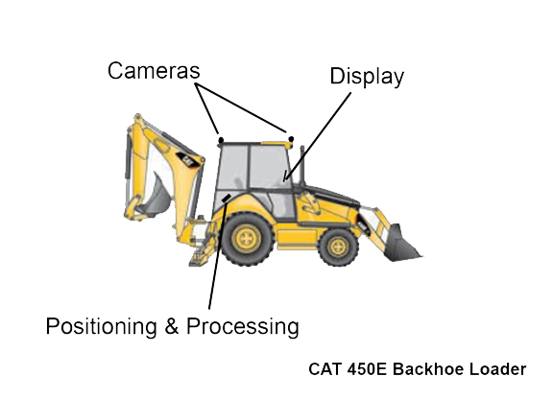

Figure 2: Display View
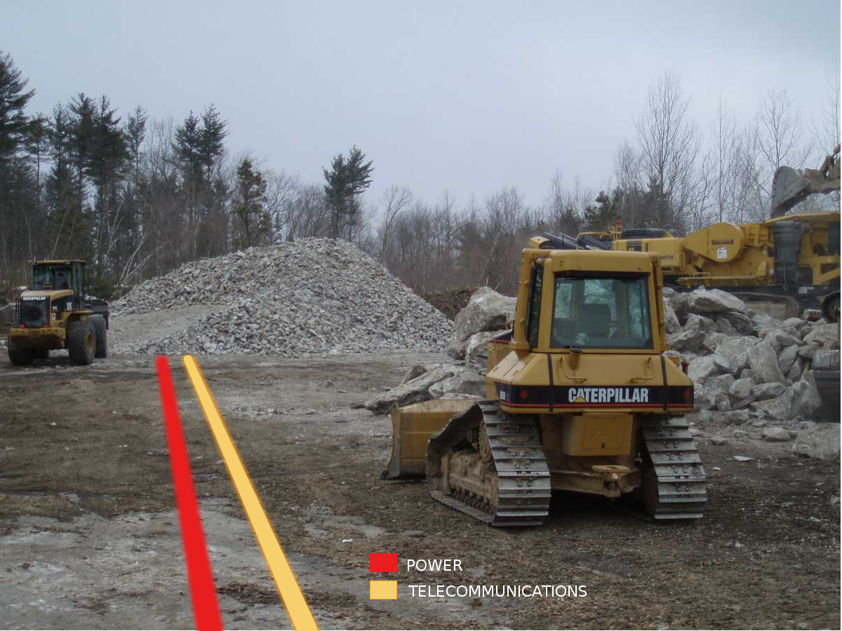

The benefits that our product provides are saving lives and decreases accidents, saving costs, and increasing productivity. Our product saves lives and decreases accidents by showing the operator of construction equipment where the hazardous areas are. For example, an operator of a piling driver would be able to see the spot where he is supposed to put the piling along with the danger areas such as the old tunnels and current tunnels. If that operator was equipped with one of our product the 1992 Chicago Flood might have been avoided.

The ability of our product to decrease the number of construction accidents would also have a cost savings benefit for such things as insurance. Most construction companies have insurance against accidents and their insurance premium goes up when an accident occurs. Thus, by stopping accidents from happening our product saves costs for our clients by keeping their insurance costs down.

Thirdly, our product is able to increase productivity by providing data directly to the operator of machinery in a visual form. Traditionally, an operator of a backhoe would have to look at construction plans to figure out where he/she has to dig. With our product, the operator does not have to spend time preparing for the dig since the information would be supplied to him/her in the field. This feature allows the operator to simply enter the backhoe and begin digging and be more accurate in his dig since he/she now has the data continually available.

Lastly, our enhanced vision system has the opportunity of many updates. The product is not limited to displaying utility information and construction plans. Our product can be programmed to display different types of information and perform different functions. For example, one future upgrade can be to keep a video log any time that an operator is too close to a utility line. This would allow for better diagnosis of the accident, to understand how to prevent it in the future and to determine who is at fault.

Concept Test and Statement
To test the validity of our product, the team conducted primary and secondary market research. We interviewed a variety of persons from professors in Civil and Architectural Engineering to safety directors of construction companies to dealers of construction equipment. Professors liked the idea and saw a definite application of our product to address construction safety; they also recognized the need of a good business model to address the market. Safety directors saw the need for more safety and dealers of construction equipment saw the uptake in safety equipment for the workplace.

Secondary research was conducted to discover comparable product and size of the market. The team was able to discover similar product such as DNR Garmin, ArcPAD by ESRI, and Topcon. The presence of these similar products demonstrates that there is a market for products that provide GIS information in places outside the office or lab. Additionally, we were able to identify features to include in our product to differentiate it from the competition.

Our product will work because there is a need for safety in the construction industry. Although there are some products offered to solve this problem, the current products do not seem to provide enough value to penetrate the market at a reasonable rate. The team was able to identify some of the shortcomings of the current products and structure our product to address these shortcomings. Through identification of these shortcomings, the team was able to design a product that would provide the most value to the customers.

Lastly, our product promotes safety in the construction industry. Safety is a major concern in an industry that is so dangerous. Extra safety provides many benefits to the companies and workers that employ them. These benefits are both monetary as well as life saving. Lastly, from a financial perspective, it is much more cost effective to prevent accidents than suffering the consequences of the accidents occurring. Hence, our product is positioned very well to succeed.

Customers
The value chain for construction equipment includes manufacturers, such as Caterpillar and Komatsu, dealers/wholesalers, leasing companies, such as Patten Industries, and the end customer. Since the product can be installed on a machine at any point in the value chain, we have a variety of ways of reaching our end customers, operators of construction machinery.

The target customer that our company will focus on first is the dealers/wholesalers and leasing companies. There are multiple reasons that these two points in the value chain were chosen. The first is their direct contact with the end customer. Since operators of construction equipment contact the dealers, developing a relationship with these dealers helps the company reach the end customer. Secondly, the dealers/wholesalers are usually leasing companies as well, which helps us target two points on the value chain through one company. The reason that leasing companies are important is because 65% of construction companies also lease equipment in the short-term if they need more machines. Thus, by getting our product installed on rental machines, more customers are able to try our product, which is a good marketing tool in the construction industry10. Lastly, the numbers of dealers/wholesalers are small and known. For example there are 63 Caterpillar dealers in North America and 220 worldwide. These small numbers of dealers allow for direct marketing and decrease the cost of our sales force.

Market Opportunity
One major pressure for construction sites is the occurrence of the utility line accidents. Current mitigating solutions include one call service such as J.U.L.I.E. and Common Ground Alliance, a government-lead organization that enforces regulations and promotes general awareness of underground utilities. However, the pressure remains severe in terms of the number of accidents and the cost of damage. In 2005, 51,600 accidents were reported nationwide with a 100% increase from that in 2004, covering gas, telecommunications and electrics. Over 75% of the time incidents caused service or distribution disruption. Significant costs resulted from utility accidents turn out as loss of life, cost of damage, service and project delays, and the consequently increased time and money. The extremely-high risk in construction sites is demonstrated by over 5,000 deaths in utility and heavy equipment accidents in 2006 alone, the average damage totals of $250 million per year since 1989, and civil penalties of $11 million a year since 2002. Our product will help ensure workers’ safety and protect professional operations. In addition, our enhanced vision system will be able to reduce a company’s cost for safety by both mitigating accidents and saving on tax and insurance expenses.

Although there are products in the marketplace that provide similar benefits, none provide data to the operator in an easy and convenient manner. For example, ArcPAD by ESRI provides utility information on a PDA but does not integrate GPS. Our product will overlay information over a camera system to provide the operator of the construction equipment with live information pertaining to where the danger areas are.

Growth Opportunity
There are three growth opportunities that our company can pursue; these are horizontally across industries, vertical across the value chain, and expanding geographically. Of the three market opportunities, expansion is the most attractive for our product because the most of the world uses construction equipment. Thus, strategies such as expanding into New York, which is the largest market in the United States, would help the company grow its sales. This strategy is the easiest to implement within the United States due to its homogeneity in construction equipment and technology. In addition it would only be a little bit harder to expand into other countries since the only thing that has to be changed is the language and adaptation of local technologies.

Although the expansion strategy is currently the most lucrative, there are other growth strategies that the company can implement. The company can choose to grow horizontally by providing similar services to other users such as fire-fighters and maintenance engineers. However, type of growth would require the creation of a new product and business to be able to tap into the markets.

Lastly, the company can choose to expand vertically along the value chain. This type of growth could include backward and forward integration. Backward integration would happen through the acquisition or merger of/with a GPS and/or GIS provider. Forward integration would occur through the acquisition or merger of/with a dealer/wholesaler of heavy machinery. Both types of vertical growth would allow the company to take better control of the products that it provides.

Business Model
The business model that the company has decided to adopt is based on outsourcing production and focusing the company’s efforts on design, quality, and customer service. Since the company does not have the resources necessary to produce the enhanced vision system at economies of scale, outsourcing the production will help the company achieve better economies of scale. Secondly, the company will focus on its business to business model of designing and selling its product. This focus will allow our company to better understand the customer which is essential in providing a continual line of products that customers will buy as well as provide insights into improving our product. Lastly we would be able to provide better product designs and customer service through a better understanding our customers.

Time-line to Launch
We have accomplished much in the last four months. After an analysis of the work done in the prior months, our team decided to focus on providing enhanced vision services to the construction industry. By making is change, our company was able to tap into discretionary spending. After we analyzed the characteristics of the three selected market segments from the previous team - large cities, theme parks, and major sporting events at selected sporting venues - we decided to use enhanced vision technology to address a more urgent and unique need. Among several possible markets we’ve looked at, we concluded construction safety to be the most appropriate market because of the crucial demand for sustainable safety enhancement in a variety of construction places.

To determine the feasibility of our product in the target market we essential market research. In addition we researched for Intellectual Property information related to similar technology. Nearly 50 patents and many more applications have been issued for augmented reality, which is the academic term for the technology that our product implements. We have yet to determine the number of those that are for safety applications. However, there is no patent that protects similar products as we are developing. We are also learning how to differentiate from the existing patents and how to apply for our own patent documents.

Until the initial launch of our product, there is still a significant amount of work to be done. Although our team has completed a significant amount of primary and secondary research, there are still a multitude of questions that need to be addressed. In addition, things such as the necessary marketing and advertising that needs to be done, additional features that can/should be integrated into our product, and further IP research to ensure freedom to operate and possibility for a patent.

Risks of business concept
Given the nature of our product and the number of patents that are already present, our business concept faces a risk of patent infringement. If a patent for our product is discovered then our company must find a method to mitigate the setback. Possible mitigations might be a royalty on sales; however this would decrease the return that our company would be able to provide.

Another risk that our company faces from the business concept is the risk of the product not performing as intended; thus failing to meet the value objectives. This would have an effect on our ability to market the product to our market. Additionally, the construction industry is highly influenced by word of mouth and recommendations. This influence means that a failure of our product would hurt our ability to sell the product tremendously.

Finally, our business concept faces typical start-up risks. These risks include the risk to make the projected number of sales and keeping costs at the budgeted level. In addition there might be associated costs that our company has not considered. To address these risks, our company has done research on typical costs associated with starting up and running a company such as this one.

Industry and Market Analysis

Description
Our objective of our business is to use Augmented Reality technology to address a more urgent and unique need. Among several possible markets we’ve looked at, we concluded construction safety to be the most appropriate market because of the crucial demand for sustainable safety enhancement in a variety of construction places.

One major pressure for construction sites is the occurrence of the utility line accidents. Current mitigating solutions include one call service such as J.U.L.I.E. and Common Ground Alliance, a government-lead organization that enforces regulations and promotes general awareness of underground utilities. However, the pressure remains severe in terms of the number of accidents and the cost of damage. In 2005, 51,600 accidents were reported nationwide with a 100% increase from that in 2004, covering gas, telecommunications and electrics. Over 75% of the time incidents caused service or distribution disruption. Significant costs resulted from utility accidents turn out as loss of life, cost of damage, service and project delays, and the consequently increased time and money. The extremely-high risk in construction sites is demonstrated by over 5,000 deaths in utility and heavy equipment accidents in 2006 alone while the average damage totals of $250 million per year since 1989. The goal of our product is to help ensure workers’ safety and protect professional operations. In addition, our Augmented Reality (AR) system will be able to reduce a company’s cost for safety by both mitigating accidents and saving on tax and insurance expenses. With use of AR, WAAS (Wide Area Augmented system) and dead reckoning system, we have created a prototype of our product which will be used in construction equipments as a better vision system and thus ensure safety.

Industry Background
The construction industry is divided into three major segments – construction of building, heavy and civil engineering construction and Specialty trade contractors. The construction of building segment includes contractors, usually called general contractors, who build residential, industrial, commercial, and other buildings. Heavy and civil engineering construction contractors build sewers, roads, highways, bridges, tunnels, and other projects. Specialty trade contractors perform specialized activities related to construction such as carpentry, painting, plumbing, and electrical work.
Construction usually is done or coordinated by general contractors, who specialize in one type of construction such as residential or commercial building. They take full responsibility for the complete job, except for specified portions of the work that may be omitted from the general contract. Although general contractors may do a portion of the work with their own crews, they often subcontract most of the work to heavy construction or specialty trade contractors.

Specialty trade contractors usually do the work of only one trade, such as painting, carpentry, or electrical work, or of two or more closely related trades, such as plumbing and heating. Beyond fitting their work to that of the other trades, specialty trade contractors have no responsibility for the structure as a whole. They obtain orders for their work from general contractors, architects, or property owners. Repair work is almost always done on direct order from owners, occupants, architects, or rental agents.

The construction industry is further divided into two major businesses areas - heavy construction equipment light construction equipment under. The construction machinery industry functions in a wide range of verticals, including residential, commercial, industrial and government or institutional. Purchasers of heavy construction equipment include construction companies, municipalities, local governments, rental fleet owners, quarrying and mining companies, waste management companies and forestry-related concerns. Purchasers of light construction equipment include contractors, residential builders, utilities, road construction companies, rental fleet owners, landscapers, logistics companies and farmers.

Some of the leading global manufacturers of construction equipments include Caterpillar Inc., Komatsu, Terex, CNH Global (CASE, New Holland, Kobelco),Volvo Construction Equipment , Deere & Company, Doosan Group (Bobcat Company), and Hitachi Construction Machinery. These manufactures sell their equipments to various dealers and distributors who then sell it to the end customer. Pattent Industries, Fabco Power Systems, Finnings are some of Caterpillar’s dealers. The construction companies include Walsh Group, Power Construction and so on.

Market Analysis
There have been several incidents that occurred in the construction areas. For example, in 1992, a flood occurred beneath the Chicago River while working on the Kinzie Street Bridge. There was an abandoned Chicago Tunnel Company tunnel beneath the river that had been used in the early twentieth century for the transportation of goods and coal. A piling was driven into the bottom of the river alongside the north wall of the old tunnel. This caused an increase in pressure that cracked the wall which resulted in mud oozing in. After a few weeks, enough mud entered to open a leak, causing a flood. The basements of several office buildings and shopping areas were flooded, shutting down the loop for three days. The cost of cleanup was in the billions of dollars, and a key commerce area was shut down, furthering losses. Had the worker been equipped with one of our augmented reality systems, this accident could have been avoided through increased awareness of key utilities or by shutting down the machinery driving the pilings.

Another incident that occurred recently gives our project a stronger purpose and a reason to exist. In a recent article, dated March 19, 2008, a nine-year old child was killed due to a fractured gas pipe in Plymouth. According to the article, a possible cause could be the previous excavation work in the area and its probable negligence. This accident and the death of a child could be avoided if the work during construction was done meticulously.

Historical successes addressing safety issues in the past include the usage of mirrors in earth movers and bulldozers, flags and sprays to mark buried utilities, back-up warnings for vehicles, fluorescent safety vests, hard hats, and more. The construction industry is being pressurized as more and more people are getting concerned about accidents and the safety of people, both in and around the construction sites. This has pushed the construction industry to build equipments that use better technology that will ensure better safety for the people. Some of these technologies include GPS integration and camera systems. These technologies have had a tremendous impact on the construction industry. They have enabled better vision for the workers which in turn increase safety. However, this has not completely solved the issue of safety and accidents in the construction areas. Hence this drives the construction industry to implement new and improved tools in their equipments to ensure safety while working in the construction sites. The U.S. market for construction machinery reached $24.8 billion in 2006, which is a 7% increase from the 2005 level of $23.2 billion. Exhibit 1 shows the increase in construction machinery market from year 1997 to 2006 (in billion).

Figure 3: Market Numbers
Source: U.S. Department of Commerce, U.S. Census Bureau; Stat-USA, USA Trade Online; calculated and estimated by SBI.

However, it is seen that there is a decline in the percentage growth and it is also forecasted that the market will slow down in the coming years and decline steadily.
There are no current companies that provide GIS (a geographic information system integrates hardware, software, and data for capturing, managing, analyzing, and displaying all forms of geographically referenced information) information to the operator construction equipment. Current substitute products are not widely used due to lack of features and integration. Our target market includes construction companies with around 35 bulldozers (with a concentration in Chicago) who further sell to end users. We plan to market and sell our product to companies that have an average of 35 bulldozers.

Porters 5 Forces
The Barrier to entry is medium. Patents and propriety knowledge tend to restrict entry into the market. Hence it is important for us to acquire Intellectual property. Although, it is the duty of the government to preserve competition through anti-trust actions, they also restrict competition through granting monopolies. The distribution channel is an important factor. Restriction in these channels can make an entry into the market difficult. Because of the growth in technology, we are at an advantage as our product uses various technologies to ensure safety.

The supplier power is very low. This is because the market for the parts used in our product is commoditized. Predatory pricing is illegal as the parts used in the product are also sold to retailers and other end customers. Hence the prices are fixed and the suppliers have no direct power over us.

The buyer power is high. Our product is new and the customers may not want to buy it because of various reasons such as price. Our goal is to ensure safety in and around the construction sites. This is crucial as no one will want to risk buying products which is new and possibly endanger people in and around the construction site. Hence it is imperative that we convince and prove to our customers about our product, that it is of high quality and will decrease the risks of accidents. This initial phase can be both lengthy as well as tasking. However, this power will diminish with time as our product will demonstrate great potential and prove itself to be an excellent equipment to ensure safety in and around the construction sites.

The threat of substitutes ranges from medium to high. Even though our product is new, there is a threat of being substituted. The one-call service of JULIE is free and this can be a threat to us as the customers might prefer to use the service instead of our product. Whether you need to perform spatial analysis, manage large amounts of spatial data, or produce cartographically appealing maps to aid in decision making, ArcGIS allows one to use one common platform to meet all your GIS needs. Both ArcGIS and the one call service very good services, however, our product has more and better features. The only challenge is that our product is new and we need to market our product effectively.

The internal rivalry is low. This is because there are not many competitors at the moment and the ones that exist are either start-up or small companies.

There is a constant increase in the concern for safety in the construction industry. Our goal is to eliminate accidents on construction sites by the use of our product and ensure safety for the people. Hence the industry is very attractive. Because of low internal rivalry, there is very little competition. Also, the products costs due to low bargaining power of suppliers will be low. However, marketing and sales will be the biggest challenge in our project. This is because our product is new and the initial phase of marketing and sales is always taxing and expensive. Hence it is important for us to set up an excellent marketing strategy, so that our product can sell successfully. Another disadvantage is that, the technological advancements in the construction industry has been very slow and is not very different from what it was ten years ago. Hence it will be difficult to market our product which uses new technologies into the construction industry.

Competitor Analysis
There are two types of competitors – indirect and direct. Our product and business faces both types of competition. Some of the indirect competitors include Garmin and GPS providers, ESRI (ArcGIS products) and JULIE GPS tells you where you are and could be integrated with GIS software to give you a location of utilities, etc. ESRI provides GIS information to users in a variety of ways. Its ArcPAD product can be considered a direct competitor but does not provide the same features. JULIE provides underground utility locating services for free. People can use it to locate underground utilities. However our product provides additional features that JULIE does not provide.
The direct competitors include DNR Garmin and ArcPAD. DNR Garmin was developed in Minnesota and provides GIS software on a Garmin GPS unit. However this product does not provide the additional features that our product provides, it only provides the core feature. ESRI product provides GIS information on a PDA. However this program does not integrate with GPS at all.
Our product is a seamless integration of GIS information, Architectural plans, and GPS. It will display enhanced vision as opposed to a map. Our will be Integrated into digging machinery (bulldozers, backhoes, etc.). Also we will ensure that our product is robust. Our main goal is to make our product high quality and hence our competitive advantage is differentiation. These features will our product unique and will put us at an advantage to others. With the use of differentiation, we will sell our products

Market Timeliness
Since ESRI ArcPAD and DNR Garmin are developing a similar product shows that the market is ready for an integrated display system for GIS information. The increased use of worksite awareness systems (i.e. the camera system on bulldozer), GPS on bulldozers, and other technologies prove that the market is ready for new safety technologies. However, the only challenge would be marketing our product since it uses new technologies that the construction industry does not usually use.

Primary Research Overview
Our primary research consists of interviews with professionals and business administrative officers. Before we conduct the interviews, we developed a generic questionnaire which addresses both business focuses and technical concerns.

After analyzing our data, we have concluded that there is a market for a product and a growing demand for the increase in safety in the construction areas. Our product is new and as a result it does require extensive marketing (which will be discussed further in the Marketing and Sales section).

Risks of Industry and Market
Even though, there is a market for our product, there are several risks that we may encounter.
Due to the current low barriers to entry, many more competitors can enter the market if these barriers are not raised. We need to license our software from other companies for our product puts a part of our product features out of our control. Also, ESRI and Garmin taking interest in the market can be disadvantageous to us as it raises the competition. We require Intellectual Property protection for our product without which we could loose our rights on our product or someone else could make the same product under legal conditions. Another great risk is that the product might not work as desired. The technical team has worked very hard in building the prototype. However, if this product is not accepted in the market like desired, then we would be running at a complete loss. Also, currently the market is in a slow period where construction purchases are few, hence marketing this product can be tasking. Sales revenue tied to the economic situation of the construction industry.

Sales and Marketing

Strategy
To introduce our product, we will have trade shows, free trials and demonstrations in all available professional occasions. According to SBI report, trials and demonstrations are vital to customers’ decision-making on purchasing innovative products for their construction machinery10. By trade shows, free trials and demonstrations through credible dealership, customers will be able to know how our product works and how it will help substantially with safety on construction sites.

Our target customers are companies that have an average of 30-35 bulldozers. We examine geographical markets separately. We will start our business in Chicago and expand to other cities with similar market size. Based on this, we project our ability to add new customers as 4 new customers per month in the first six months of operating in a market. After that the number of new customers would decline to one per month. Hence, we consider the market is saturated. At first, we will mainly accomplish this goal every month through the trade shows, free trials, demonstrations and other promotion activities. Later on, as long as we gain reputation and trust by word of mouth, customers may come to us to get the product.

We assume each new customer will buy 1 unit in the first month after they experienced our demonstration and free trial. They will be allowed to try our product without paying for it for this first unit. After that, we anticipate a 95% customer retention rate. Thus, in case of we getting 5 new customers purchase the first unit per month, 4 out of 5 customers per month will decide to adopt more of our products while 1 customer may drop out after the first month. The 4 customers are considered to get into their next phase – 7-month phase. In the next seven months, we predict they will buy 5 units per month in reference of the average number of bulldozers each customer has is estimated at 35.

Hence after these seven months, they will have our system installed in almost all of their bulldozers. Then they get into after-7-month phase, which we will sell only 1 unit per month to 5% of old customers in general. These three phases is the assumption for each customer we get, that is, we assume each of our customers will get into these three phases as long as they continue to purchase after the first month. We will continue to get new customers at the same time we serve the old customers until the geographic market is saturated.

After two years, we assume the Chicago market will be close to full. Therefore, we will be ready to enter a new geographical market. We expect the new market to be a similar one as Chicago in terms of market size and geographical location.

Marketing

Target Market Customer Profile
We sell our system to construction companies who own bulldozers and companies who lease bulldozers to other construction groups. As far as we researched, a lot of construction companies and dealers lease bulldozers that are not in use to outside construction groups to achieve higher usage rate of their equipment. Our primary target is bulldozer companies that have an average of around 35 bulldozers. We generate our financial model based on this estimation.

4P's
Product: Enhanced Vision System that raise safety level in construction sites by providing information from both construction plans and professional databases and overlaying them to a camera system. Customers can benefit from our product in terms of decreasing accidents and increasing productivity by showing the operator of construction equipment where the hazardous areas are. Therefore, companies will be able to save lives and reduce costs. The product will first serve bulldozers.

Price: We will sell our system at $5000 in the first year, which we believe is a very low price for our product. We projected to sell $8,000/unit for the second year, and $10,000/unit for the third year. This price projection is based on the sales of similar products, cost of a camera system as well as cost of integrating. The cost is set at 44% of price for direct materials, $180 for direct labor, and $120 for quality assurance.

There are some products which help increase safety level on construction sites. They are priced much higher than ours. For example, the Topcon product is priced more than $15000 and it does not have the innovative and direct benefits that we do. Our price is low since our product provides substantial cost savings. One main saving is insurance cost. Insurance in construction is very high due to the severe consequences if any accident happens. Although we did a lot of research, we could not find hard statistical evidence on the insurance costs because it’s business confidential. But it’s quite possible that the initial and monthly payments for insurance could be deducted upon employing our product. We could charge up to $15,000 in consideration of the benefits out product could provide for customers both financially and for intangible assets. But we decided not to. One main reason we decide to price it much lower than it could be is we want to encourage the end customers to purchase the units so that we could penetrate the market faster at the early stage of our business. However, $5000 is still a reasonable and promising price because we will still be able to have a 50% return on investment per year with $5000.

Place: Basically, we will sell our product through three channels: dealers/wholesalers, leasing companies and manufactures. Our Primary target is dealers/wholesalers because they have a direct connection to the end users and pretty much every issue the customers have goes back to dealers/wholesalers. Credible dealership is a key component to purchase innovative products for construction companies10.

Figure 4: Distribution Channel
US
Dealers/Wholesalers
Manufacturers
Leasing Companies
End Customers

Promotion:
We will raise the awareness of our product through trade shows, free trials, demonstrations, and print media. Trials are important because it will be more informational asking the customers to have hand-on experience with the product.

Multi-channel, integrated and virtual marketing tactics are vital to reach construction machinery audiences. (SBI report) By convention, we will advertise our product through traditional general media, direct mails and specialized design and industrial magazines such as “Construction Equipment” and “Equipment World”. We will also participate in international and domestic trade shows as well as cooperative advertising campaigns with dealers and wholesalers. We will make advantage of the technology development occurring in marketing activities by promoting our product through multiple web-based advertising and virtual demonstration. Online advertising market is reported to be a booming zone over years. (SBI report) Our official website will have up-to-date content of our product, videos of real product demonstration technical support directly available to end-users. There will also be a mailing list and a forum page to get customers aware of updated information and provide a channel for instant communication.

Budget
We estimate $1.8 million dollars in cash for startup expenses, initial operating costs, and working capital. Full projections for budget are given in the appendix.

Our system is an innovative solution to increase safety assurance in construction and utility sites. It would be a tough task to get customers to accept our product after they know about it. We allow a pure 30-day trial upon first purchase, which would potentially rise up the cost for providing trials. Moreover, advertising tactics through internet ask for fees paying to public websites as well as expense on building up our own online system.
One of our future goals is to break down marketing costs and give a better estimate of our marketing costs based on more pre-determined marketing steps.

Risks of Marketing and Sales
One major risk we are facing is our estimates and assumptions may not be accurate. There is a risk that it’s too difficult to carry out our pre-defined sales goals due to practical market size and adoption rates in the market.

We think 5 new customers per month to purchase their first unit in the first six month is a realistic goal for sales. However, there could be a possibility that bulldozer companies are a little bit more conservative to try out new technology than we expect. We believe the customers will like our product after they use it in real workplace and will continue to purchase until they have it installed in all of their machinery. But they might not be very satisfied with the real effects after trial. In that case, we may need to modify our system based on their feedback, which would result in longer time for product development and extra expenses. Another consequence could be it takes a longer time for the end-users to adopt our product than one month. Then we may need to allow a longer period before the first unit is taken at the initial stage. Besides, we assume in the after-7-month stage, generally 5% old customers on average will purchase 1 unit for each month. However, with the technology develops, the lifetime for bulldozers may be prolonged. Then the purchase rate for new bulldozers may be reduced. This might directly influence their adoption rate of our product. In this case, we may have to enter new geographical markets sooner than we predict.

The financial model is based on a healthy and booming economic environment. Theoretically, there is risk coming along with recession or critical social threat, which we do not see so far.

Management
We have Professor James Burstein and Professor John Stoner as our advisors. Dev was designated as the team leader. The EnPRO team is divided into business sub-team and technology sub-team based on every member’s preferences and backgrounds. Every member works specifically to one of the functional team and devote to the cross-functional EnPRO team at the same time.

We have Professor James Burstein and Professor John Stoner as our advisors. Dev was designated as the overall team leader, primary team scheduler and iGroups coordinator. Vlad and Savina co-lead the business team which includes Dev and Meng. Jeff is the team leader for technology sub-group which Adam, Max and Tim contribute to. Vlad is the coordinator for the IPRO sub-team which helps specifically with project deliverables and IPRO Day activities. Meng is the time-keeper and minutes-taker for the class meeting sessions.

The technology team is responsible for heading the technical research, designing and integrating the prototype as well as dealing with technical concerns through the project. Each member from the sub-group is responsible for managing a major section of the project tasks. As the team leader, Jeff is responsible for administrating team tasks and progress, and scheduling assignments within the sub-group. The technology team successfully provides a functioning prototype that is ready to be demonstrated at IPRO Day.

The business team devotes to carrying out market research, creating business model and preparing financial projections to support the main deliverables. The team manages the completion of the project documents with the help of technology team and provides marketing information for technology team to tailor the technical specs of the prototype. The business team handled both the primary and secondary market researches, develops the business model and financial projections as well as other supporting material.

The IPRO Day group is building to focus on major deliverables and IPRO Day tasks. The team consists of members from both sub-teams to collaborate efficiently to completing IPRO deliverables and demonstrate an effective exhibit and presentation to judgers and investors.

Both of the sub-groups meet outside class regularly to accomplish scheduled tasks. The entire team meets several times to complete specific deliverables and to mitigate potential communication problems. Every sub-team meeting discussion is traced by one of the sub-team member. Every team member is assigned explicit tasks for each deliverable and other work within the team. However, team members help each other anytime to smooth things out.

The team maintains a good balance of technical and business efforts as three members are business major and the others are from technical majors. The business team has three business majors -- Devaraj Ramsamy is a 4th year Finance major, Vlad Rusz is a 3rd year Finance & International Business major and Savina Jose is a 3rd year Marketing & Human Resources major. – and a member with technical background -- Meng Zhang is a 4th year Information Technology & Management major and Business minor. The technology team has three engineering majors and a applied math major -- Jeffrey Mizek is a 3rd year Electrical Engineering major, Adam Bain is a 4th year Computer Engineering & Computer Science major, Maximillian Estrada is a 3rd year Aerospace Engineering major and Timothy Madsen is a 4th year Applied Mathematics major. Each of them focuses on specific area of developing the prototype and other tasks within the sub-group based on their specialty.

Financials

Overview
Given our projections, the internal rate of return for the investment is 86% per year for the first there years of operations. This timeframe includes the initial six months spend on developing the product to a production stage. Our financial projections were generated by estimating revenues and costs at the most basic levels in order to get better estimates. This way, if one projection is wrong it should not have a wide impact on our overall financial situation. The main assumptions discussed are customers, unit sales, and price and cost of the product.

Assumptions
Our first assumption is our ability to add new customers. This assumption is affected by our definition of a market as construction companies that own on average of 30-35 construction machines in the same geographical area. We project that for the first six months of operating in a market we would be able to add four new customers per month. After six months of operating in a market that number of new customers would decline to one customer per month. Thus, this assumes a market maturity of six months.

Next we projected the number of unit sales to each customer. In the first month, we would sell one unit to each customer added that month on terms of net 30. This allows our customers to try our product for 30 days without paying for it. From the customers that try our product, 95% would choose to continue buying the product. After the initial sale, a reasonable assumption would be that we would sell five units per month to each customer added in the last seven months. After seven months, the number of unit sales would be 0.05 or five percent of customers older than seven months would buy a unit from us. Thus, we projected that a customer would buy most units in the first seven months.

An adjacent projection to number of unit sales are the price, cost, and profit made on each unit. We projected that the product would sell around $5,000/unit in the first year, $8,000/unit for the second year, and $10,000/unit for the third year. This price projection is based on the sales of similar products. The cost projection for the product is based on the amount that each part costs and is widely based from the cost of a camera system and the cost of our prototype. The cost is thus set at 44% of price for direct materials, $180 for direct labor, and $120 for quality assurance.

Inventory levels are calculated as three months in 2009, two months in 2010, and one month in 2011. The reason for these projections is based on economies of scale. The first year of operations is only six months since sales only start in June. Thus the amount of units needed is smaller and thus a larger amount of inventory must be kept. As the amount of unit sales increase, the company can hold less and less inventory to reduce the amount of working capital needed.

Figure 5: Results of Financial Projections

The chart represents the results of the assumptions made about sales and costs of the company for the next three years. These projections show that the company’s monthly accounting break even (i.e. the first month when net income becomes positive) is December 2009. This quick turn to profitability occurs due to the company’s high operating margin. Additionally, the overall accounting break even occurs in June 2010. This overall accounting break even is important due to the tax implications of being a profitable company. Thus, due to the quick turn to profitability, the company is required to use valuable cash to pay taxes.

The next item, and arguably the most important, is the cash flow analysis. Monthly cash flow becomes positive in July 2010 and the company’s cash accounts become positive in November 2010. The key things to note are the affect of income taxes and inventory policy on cash flow. The sharp movements in cash flows after June 2010 are due to income taxes. Additionally in December 2009 the company decreases its inventory to two months and in December 2010 the company decreases inventory to one month which frees up working capital and thus increases the amount of monthly cash flow. In conclusion, the turn to positive cash flow and positive cash is relatively fast but affected by taxes and inventory holdings.

Capital Requirements
Given these projections, our company needs $1.8 million dollars in cash for startup expenses, initial operating costs, and, most importantly, working capital. Based on who the investor is, the amount of equity that the company would have to issue differs. These different projections for post-money valuation are given in the appendix.

Table of Appendices
Business Concept 30
Code of Ethics 30
Creative Variables Chart 33
Growth Chart 33
Value Chain 33
Organization 34
Organizational Chart and Roles 35
Hourly Work Distribution 36
Budget 36
Industry/Market 37
Industry Growth Charts 37
Competitive elements across industry 37
Strategy 37
Value Chain 37
Product/Service vs. Capabilities chart 38
Strategic Position 38
Financial 38
Assumptions 38
Pro Forma Financial Statements 39
Unit Sales Projections 40
Pro Forma Income Statement 42
Pro Forma Balance Sheet 43

Appendix

Business Concept

Code of Ethics

Refer to The Seven Layers of Integrity by June Ferrill

Overarching principle:
Our team will develop and design an augmented reality safety system that provides accurate, reliable and timely information. We are dedicated to providing critical data to construction persons in order to save lives and prevent accidents.

- Law and Regulations:
Canon: We will comply with all intellectual property and regulatory laws to the best of our abilities.

Pressure: To make a product that does not infringe on other intellectual property.
Risk: Not doing enough research into patents that exist on augmented reality and infringing on other patents.
Risk: The patent research being performed too narrowly and other non augmented reality patents being infringed.
Measure: Being threatened with law suites due to patent infringement.

Pressure: To complete the work and building the prototype on time.
Risk: Exposing the project to unnecessary liabilities due to the legal and regulatory research being insufficient due to time restrictions.

2) Contracts:
Canon: We will abide by all the terms of the contracts and all non disclosure agreement that apply to our project.

Pressure: To use the prototype hardware for personal or non project related uses due to the hardware’s other functions, such as using the GPS device for car navigation.
Risk: Violating terms of contracts with sponsors which can lead to withdraw of support.
Measure: Sponsors withdrawing their support for the project.

Pressure: Needing assistance from third parties for equipment operation and prototype building.
Risk: Violating non disclosure agreements.
Risk: Releasing trade secrets to outside parties.
Measure: Trade secrets being stolen and patented.

3) Professional Codes:
Canon: We will abide by the construction industry professional codes as pertaining to safety equipment.

Pressure: Create the most affordable prototype possible.
Risk: The product not providing any real value.
Risk: Not considering quality and safety issues in lieu of price.
Risk: Prototype not actually providing valuable information to the user and not providing any extra safety.

Pressure: Create the highest quality prototype.
Risk: Few consumers will be able to take advantage of its life saving ability due to its high price.
Measure: The change or lack thereof the number of recorded fatalities and accidents in the construction industry.

4) Business and Industry Standards:
Canon: Performing to the highest ethical standards of the construction and safety industry, keeping in mind that our product saves lives.

Pressure: To produce a prototype as quickly as possible.
Risk: Disregarding the new safety issues that our product will create.
Risk: The production of a dangerous prototype
Risk: The product not being thoroughly tested in the field and thus not being guaranteed to be reliable.
Measure: Obtaining a safety certification from such organizations as OSHA.

Pressure: To produce a product that is robust.
Risk: The inability to efficiently test the product due to its many functions.

5) Community
Canon: The team will thoroughly test and ensure the product provides the best safety and most value to the communities in which our product is used.

Pressure: Get product to market as soon as possible.
Risk: Product is not thoroughly tested and does not provide the intended value.
Risk: Putting the community at serious risk due to malfunction of the product.
Risk: Business fundamentals of the product are not properly researched to provide the most value to the community.
Measure: Legal action taken against the product’s manufacturers by stakeholders.

6) Personal Relations:
Canon: The team will respect each other’s opinions and completed work.

Pressure: To have a team and sub teams with a significant amount of autonomy.
Risk: Sub teams not understanding each other’s work.
Risk: Project being delayed due to lengthened discussions and team member conflict.

Pressure: To complete a large, varied amount of work in a short amount of time, such as weekly deliverables
Risk: Team members taking credit for other work.
Measure: Peer review at end of project

7) Moral Values;
Canon: No team member will be required to do anything that violates their own personal, religious, moral, or ethical beliefs.

Pressure: The need to work outside of class.
Risk: Working on days that some consider religious holidays.

Pressure: To complete all assigned work on time.
Risk: Forcing a member to violate personal morals or values to meet deadlines.
Measure: Member brings up situation to team publicly or privately to the proper hierarchical person, possibly the team leader.

Creative Variables Chart

Growth Chart

Value Chain
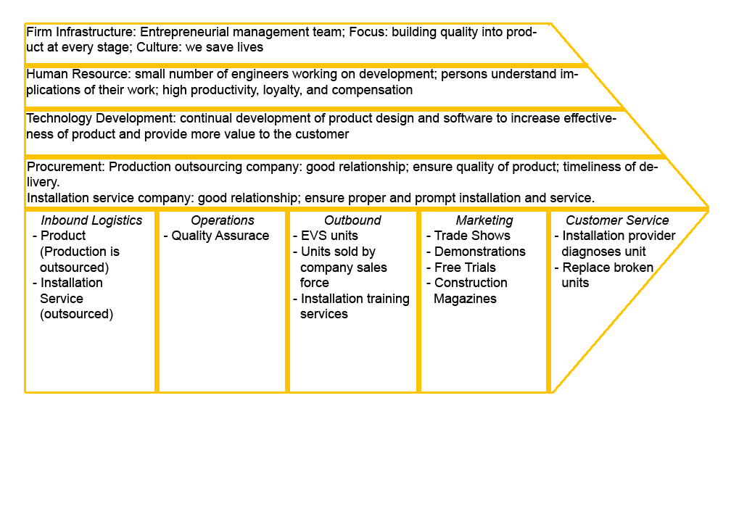

Organization
Task Outline 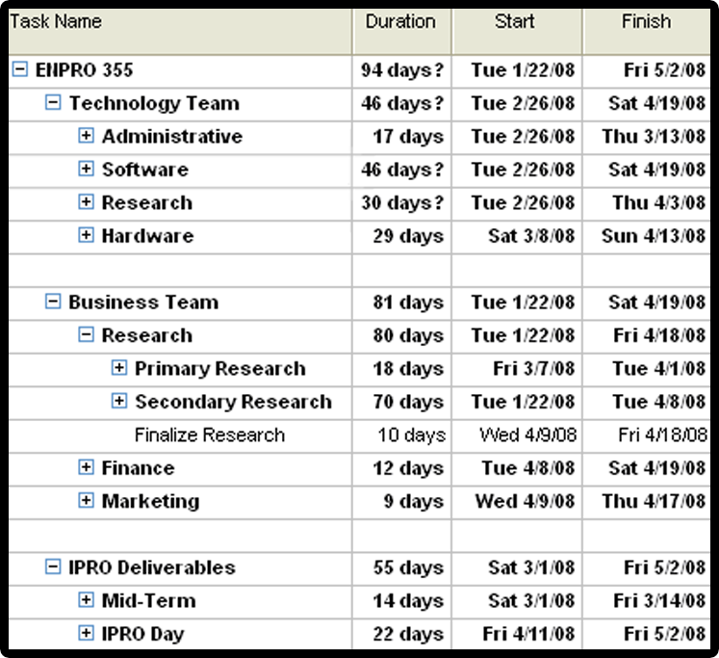

Organizational Chart and Roles
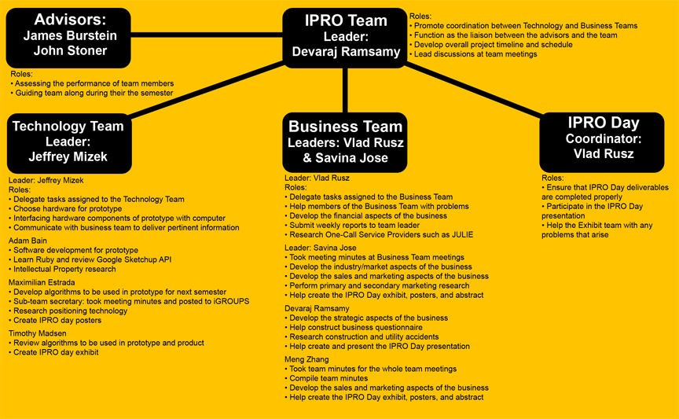

Hourly Work Distribution
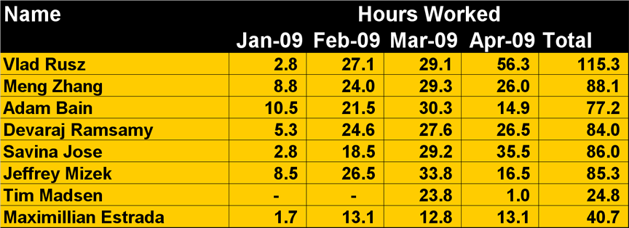

Budget
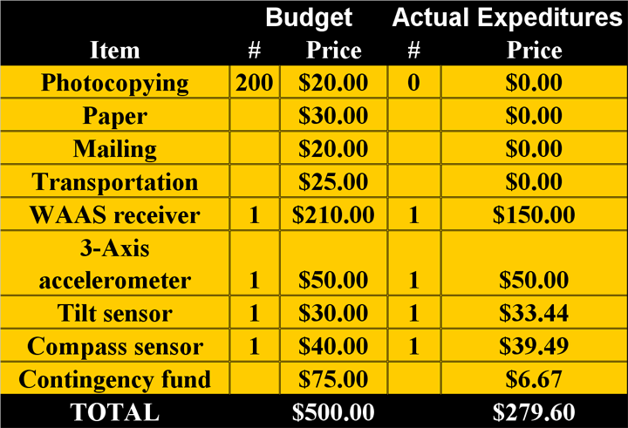

Industry/Market

Industry Growth Charts

Competitive elements across industry

Strategy

Value Chain

Product/Service vs. Capabilities chart

Strategic Position

Financial

Assumptions
To get a better estimate of the financial return that this project will provide, our team has made the following assumptions:

- A market is defined as companies that own on average 30-35 bulldozers in the same geographical area such as Chicago, New York, and Los Angeles.
- Monthly sales are calculated in the following manner
  - Four (4) new customers will be added for each market that the company entered within the last six (6) months
  - One (1) new customer will be added for each market that the company entered prior to the last six (6) months
  - 95% of new customer will be retained as old customers
  - Five (5) units will be sold to each customer added in the last 7 months
  - Five (5) percent of customers added prior to the last 7 months will purchase one unit (Alternatively this can be calculated as 0.05 units sold to each customer added prior to the last 7 months)

Discussion:
The first assumption is our ability to add new customers. This assumption is affected by our definition of a market as construction companies that own on average of 30-35 construction machines in the same geographical area. We project that for the first six months of operating in a market we would be able to add four new customers per month. After six months of operating in a market that number of new customers would decline to one customer per month. Thus, this assumes a market maturity of six months.

Next we projected the number of unit sales to each customer. In the first month, we would sell one unit to each customer added that month on terms of net 30. This allows our customers to try our product for 30 days without paying for it. From the customers that try our product, 95% would choose to continue buying the product. After the initial sale, a reasonable assumption would be that we would sell five units per month to each customer added in the last seven months. After seven months, the number of unit sales would be 0.05 or five percent of customers older than seven months would buy a unit from us. Thus, we projected that a customer would buy most units in the first seven months.

- The price for the product is implied as follows
  - Year 1 Price: $5,000
  - Year 2 Price: $8,000
  - Year 3 Price: $10,000
- The cost for the product is implied as follows
  - Direct Material: 44% of Price
  - Direct Labor: $180
  - Quality Assurance: $120

Discussion:
An adjacent projection to number of unit sales are the price, cost, and profit made on each unit. We projected that the product would sell around $5,000/unit in the first year, $8,000/unit for the second year, and $10,000/unit for the third year. This price projection is based on the sales of similar products. The cost projection for the product is based on the amount that each part costs and is widely based from the cost of a camera system and the cost of our prototype. The cost is thus set at 44% of price for direct materials, $180 for direct labor, and $120 for quality assurance.

- The inventory levels are calculated as follows
  - 2009: 3 months
  - 2010: 2 months
  - 2011: 1 month

Discussion:
Inventory levels are calculated as three months in 2009, two months in 2010, and one month in 2011. The reason for these projections is based on economies of scale. The first year of operations is only six months since sales only start in June. Thus the amount of units needed is smaller and thus a larger amount of inventory must be kept. As the amount of unit sales increase, the company can hold less and less inventory to reduce the amount of working capital needed.

- The assumptions for the operating costs of the company are as follows
  - Insurance: 1% of sales
  - Marketing and Sales: 20% of Gross Profit
  - Rent: $3,000/month
    - Calculated as 3000 sq. ft. for $1/sq. ft.
    - The office space would be used by both administrative and development departments
  - Repairs and Maintenance: 0.2% of Net Sales calculated as
    - Failure rate of 2% of units sold
    - Repair cost of 10% of sales
- Employment needs are assumed as follows
  - The CEO would receive a yearly salary of $150,000 paid monthly
  - Three (3) administrators would be hired with a salary of $100,000 each
  - Six (6) engineers would be hired with a salary of $80,000 each
  - Benefits cost to the company are calculated at 20% of monthly salaries paid
- Tax
  - The company operates in a 25% tax bracket

Pro Forma Financial Statements

Unit Sales Projections

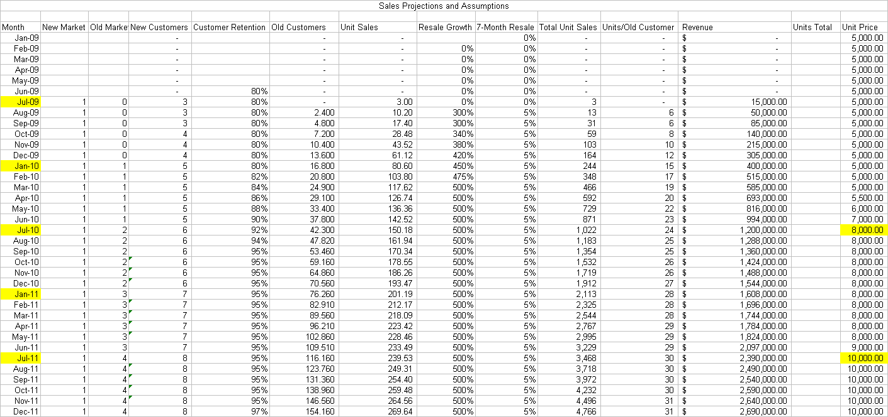

Pro Forma Income Statement
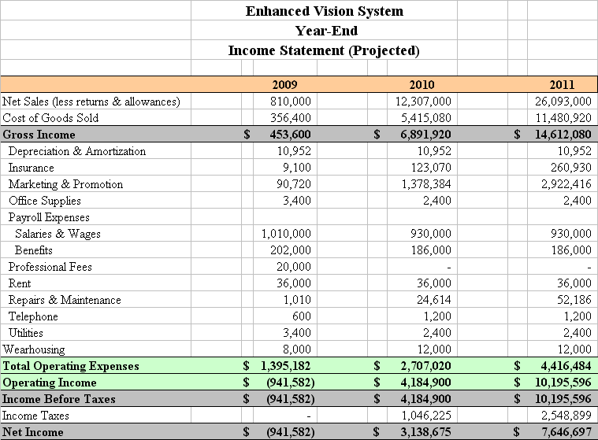

Pro Forma Balance Sheet
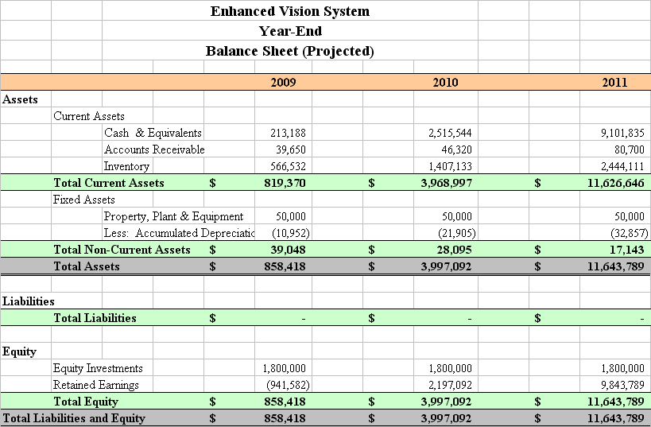

Cash Flow Projections
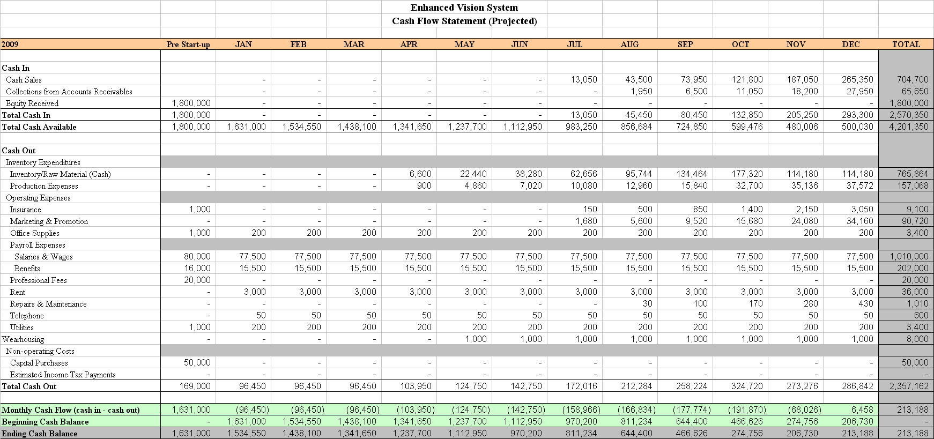
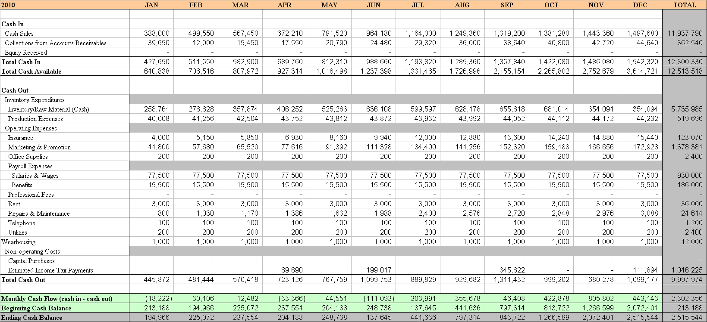
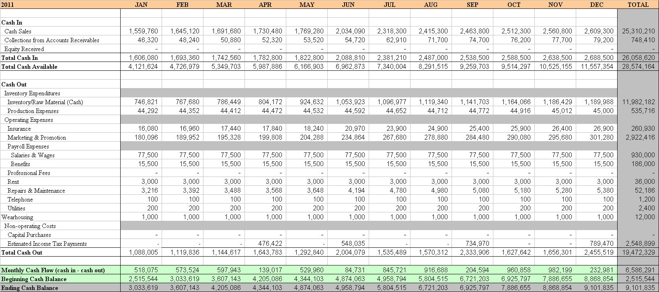

Reference

Reference for Kinzie Street Accident
UK Girl
CAE Professors Interviews
Safety Director of Power
Equipment dealers
DNR Garmin
ArcPAD
Topcon
Dealers and Value Chain (mostly 10-K reports)
SBI p. 26
10 SBI p.149
Cat 10-k annual and www.cat.com
J.U.L.I.E website
Common Ground Alliance
Damage Report
Chicago and New York market size (MarketResearch.com – Construction Machinery Sales Outlook)
50 Patents for augmented reality
1
1

