IPRO 332:

Our Energy Future: Lessons in Sustainability
Fall 2009
Instructor: Jim Braband

Illinois Institute of Technology IPRO 332

1. Team Information

Member | Strengths | Knowledge/Skills to Develop | Overall Expectations
Jorge | AutoCAD, Revit, illustrator, photoshop | presentation skills, teaching, punctuality | To be able to teach elementary school level children how to live sustainably.
Jason | Editing, Experienced with InDesign, | Teamwork, communicating with a group | To create a successful project with a large group and develop good teamwork skills.
Gina | organization, research, commitment | presentation and marketing skills, information on sustainability | To create a project that IIT will help support and attach its name to.
Ross | basic computer programming in multiple languages, Knowledge on LEED | presentation skills, teamwork | create a useful teaching module for students
Livia | Organization, visual presentation/graphic skills, documentation | communication/ presentation skills | learning more about sustainability and the effective way to teach others about it
Declain | graphic skills with various media, organization, design of presentation and tools | communication, teamwork, final product refinement | further investigate sustainability, develop applications for younger audiences
Nam | Research, documentation, organization | Communication and presentation | Learn more about team work, and energy projects
Patrick | “hands-on” projects, creating presentations, researching topics, up to date with current topics. | Learn to better communicate and stay in contact with what is going on in the group. | learning how to teach kids in grade schools and high-schools through teaching modules
Jennifer | Communication, Oral presentation, documentation, organization, working well within a group | sharing more ideas, knowing the dynamics of sustainability | Learning new innovative ways to inform others about sustainability
Micheal | Hands on Technician, Decent Communication and Presentation Skills, Time Management and Financial Organization, and average on working with people. | Patience with People, how to deliver information more clearly, and focusing on all aspects of a task/project. | Becoming more educated on aspects of Energy and Harvesting of Energy.
Mayra | Organization, Scheduling, Commitment, AutoCad, Photoshop, Illustrator | Presentation skills | To develop a system in which our efforts can be known for as well as integrating a branding approach for IIT support.
Andrew | Planning, organizing and working with people. | How to put together a teaching module and more information on energy sustainability. | To put together effective teaching modules and market them to the community.
Gregory | Prior IPRO in green technology and able to research new ideas and comprehend them quickly | Working to complete tasks in a timely manor to keep the group on track | Create a new module that shows what is learned in the classroom can be used in real life.

2. Team Purpose and Objectives

The mission of our IPRO is to educate the community, focusing mainly on elementary and high school students, on the issues of sustainability and energy conservation. Our group looks to expand on the work that has been completed in previous semesters, by adding multi-media presentations to enhance the current teaching modules. Previous modules have presented to classrooms simply with information, and our group looks to add upon this by adding interactive and entertaining materials to intrigue our audience.

This semester, we look to develop a new module that introduces the idea of a “zero energy” home to high school students. This module will deliver the facts in an unbiased fashion and educate high school students in the simple actions they can take to save energy. With all the work completed over the past semesters, we hope to advertise to a large market of teachers, administrators, and superintendents to gain awareness of what the IPRO has accomplished and in hopes they will use it in their districts.

- Enhance the “Tree Farming” teaching kit to a more sophisticated level for high school students by including more science, making the kits more informative through the use of statistics, and adding more multimedia activities, visual aids, and in-class experiments

- Prove (Demonstrate) the effectiveness of the existing teaching kit materials on students and teachers

- Develop a unified aspect of the teaching kits on how they are related and tie them together, mainly focusing on how energy ties them together

- Establish an after school program that will teach elementary school students about sustainability with the help of the teaching kits made by IPRO 332

- Obtain the endorsement of IIT for the efforts of IPRO 332 as well as the Teacher Knowledge Share website (www.teacherknowledgeshare.com)

- Promote and create interest in the Teacher Knowledge Share website

- Create working relationships with organizations outside of IIT

- Interact with the general public at different sustainability events to inform them about energy issues and ways that they can help to reverse the damage that has been done

- Develop and finalize a new and unique sustainability module for IPRO 332 focusing on the zero energy house to be introduced to high school level students

- Support findings and final product with concrete data and statistics which define the effectiveness of the new module

3. Background

Energy sustainability has quickly become one of the most prominent topics in our society today. Scientists believe that our fuel reserves are beginning to drain and that we must conserve what we have and develop new energy sources to continue our way of life.
Given the importance of this issue it is no surprise that one of the most important steps in working towards a brighter energy future is to educate children on what can be done and what is being done. By giving children grounding in the many ways in which energy can be conserved and generated we are attempting to ensure that they will apply these methods in their everyday life. This will hopefully lead to a generation of people who are energy conscious and work for the betterment of the planet.

IPRO 332 is in its sixth semester and has become a well established project. The strong work of previous semesters’ teams has given the current team a good base to start from in furthering our goal of energy education. The teaching modules passed on from previous semesters are very detailed and well researched. This semester the goal is to expand upon the modules that have already been made, explore the creation of a new module and market our modules in the surrounding communities.

The teaching kits will be updated using current information where needed. In addition they will be made to suit many different audiences. The kits will then be marketed using many different media. A new kit will be created to examine new technologies and potentially create a module to connect all of the current modules.

Ethics remains one of the important issues that must be considered in this project. All presentations and media must remain unbiased so that the students will receive a fair presentation of the issues facing our society. This has been successfully achieved in the past and will continue with this current team.

4. Team Values Statement

As a composite, IPRO 332 and 320 determined to hold the involved individuals to set standards: commitment, communication, cooperation, motivation and quality.

- Commitment: It is expected that all individuals execute each task, which they are assigned. Within this general statement, each member will be held accountable for the collaboration needed for set task. There is a need for individuals to be dedicated without needing excess instruction from the group.
- Communication: It is expected that there be a habitual form of discussion within the group. Each individual is accountable for informing the entirety of the group on their ideas, i.e., through means of iGroups, reports and e-mail. The content of such correspondence is to be with full honesty therefore allowing for constructive criticism to emerge.
- Cooperation: It is expected that there be a balance between every individual of the group therefore allowing for the advancement of any tasks in progress. There is a level of professionalism with which all tasks must be completed, i.e., if a compromise must be reached, all individuals will discuss and collaborate until it is finalized. All individuals should be inclined to finish tasks although it is not their assignment.
- Motivation: It is expected for each individual to be stimulated to further make progress on any task. This in turn, will allow for more proactive results seeing as how more things will be accomplished faster.
- Quality: It is expected that all individuals complete all assigned tasks to a certain level of finesse. This level of standard will benefit the group by allowing for the easy access to previous data and will also aid all future groups in there research of previous activities.

5. Methodology/Brainstorm/Work Breakdown Structure
With a growing need to raise awareness with respect to rising energy demands, the challenge of creating such awareness among young adults has been placed before us. A foundation on solving this problem has been established by previous IPRO 332 teams with the establishment of a website, two educational modules for high school students concerning the topics of the “Ecological Footprint” and “Cradle-to-Cradle,” and an additional module for elementary students which includes 3 lessons: Tree Farming, Paper Making, and Continuous Life Cycle or End Life. It is now the challenge of the current IPRO to investigate and implement tactics to further this awareness among individuals on a much greater scale. In order to achieve this goal, there are questions that need to be addressed:
- Do we need another module to expand the material and introduce new information on sustainability?
- What is our marketing strategy to attract more audience?
- How can this information be tailored to each individual’s intellect and interest level in a better way?

The current IPRO 332 will address the problem in a few key ways. IPRO 332 will divide the work among three sub teams:
- Zero Energy Home sub team
- Marketing sub team
- Teaching Kit sub team

To address the first question, sub team 1 will be responsible for creating a completely new module that will eventually be used by teachers to help present and explain the topic of zero energy homes and real fixes. This sub team hopes to compile all knowledge found into a basic, concentrated kit that can be taught and presented by teachers to school kids, or even just to the general public for exhibition. The module will consist of paper and electronic documentation for the administrators to follow, some type of multimedia presentations (such as PowerPoint), and different types of interactive activities for the participants to learn from. The finishing product will be a module that is fun and educational, and is seen as a good tool that will be used for a large audience.
The zero energy home module will consist of two main sub-topics; the zero energy home and real life energy fixes. The zero energy home portion will primarily deal with explaining and presenting the newest types of technology and methods being developed to help reduce a homeowner’s usage of energy. Pictures and models will be used to help better understand the reasoning behind the making of such a complex structure. The real life energy fixes part of the module will be more oriented to showing what can be done by the average person to cut down on home energy usage. This will most likely include presenting incandescent light bulbs, home weather stripping, and even explaining topics such as “stand-by” power usage taken by computers.
Much of this sub team’s time will be devoted to researching the chosen topic. One of the first objectives will be to go and visit the “Zero Energy Home” display in Chicago to get a general understanding of the topic and to help come up with ideas for the module. We would also like to get in contact with other “Zero Energy” groups (such as previous IPROs) and see what we can learn from them.
The second question will be addressed by the sub team 2. The main objective of this sub group is to market the activities of the former, present, and future students of IPRO 332. We hope that through educating the community at large on the different activities of our IPRO they will find motivation to help our cause of further educating the community on sustainability. One way this sub group plans to further market the IPRO’s activities is on Facebook. Through Facebook the group will be able to create a means of simple, global, and free of charge marketing. Facebook currently houses more than 250 million active users worldwide and is available in 47 different languages, making it easier to reach a more international audience. By creating a Facbook group with an IIT name dedicated to informing the public on the different activities that the group will be hosting, we will be able to attract more attention to what we are doing.
Another way in which the group will further be able to market the IPRO 332’s efforts is through the various community outreach activities they will host. The marketing sub team plans on having “Earth Days” hosted either at parks or in local schools at which they can have activities where testing of the teaching kits can be made possible. General knowledge booths (for those that wish to take a less interactive approach to learning) will also be available. In addition, after school functions will be hosted. These after school functions will provide further possibilities to test the teaching kits with elementary school level children.
Because the issue of sustainability should not just be undertaken by a handful of people, this sub team plans to work closely with other IPROs that have similar causes. The group will also work more closely with IIT. By establishing more concrete connections with IIT, the group hopes to link the Teacher Knowledge Share website to IIT’s. In addition, the group will try to establish semi-permanent displays in educational institutions where information on activities, events, teaching materials, and communication can be posted.
The question on how to adapt the information IPRO 332 is presenting to specific audiences will addressed by sub team 3. This group will work on how to improve and enhance the existing teaching kits. The team will organize the information based on age. Because this group will be tailoring to elder grade levels, the information and statistics provided will be more sophisticated than in previous teaching kits. The groups’ effort will be focused on the Tree Farming module, as it needs the most improvement.
Analyzing the reactions and suggestions of the audience is essential to the perpetual improvement of the product and services this group aims to provide. The team will deliver the outreach to several schools in the city to test the modifications of the teaching kits. They will do more multimedia activities with teachers and students to make the IPRO’s execution more interactive. Mobile equipment and in-class experiments will be utilized. Better visual aides, such as new slides and displays to better present the module will also be used. In order to create a more competitive environment, as well as a better learning experience, quizzes will be created. Interaction with teachers will be possible through seminars regarding the teaching kits. In order to create more effective kits, feedback will be retrieved from the administrators of these kits. Individual feedback worksheets for students as well as teachers will also be passed out in order to record the effectiveness of the kits. By collecting reactions and suggestions from teachers further improvement will be possible. This data will be archived according to school and date. After studying the feedback and the tests, this team will have a summary of the good and bad aspects of the presentation and kit.
Prior to the final presentation, this team will assess the accomplishments and create a report to analyze exactly how successful/effective the teaching kits have been. This analysis will be based on previous testing and documentation outlined. Finally, the results of this analysis will be compared to the work of last semester’s and used as a basis for recommendations on the possible continuation of this IPRO.
6. Expected Results

- The activities for the project are divided amongst three categories: refining modules for elementary and high school levels, developing a module about a zero energy home, and marketing and making our material available to a broader audience. Included in the marketing is to broaden the audience of the Teacher Knowledge Share website as well as the beginning of an implementation of lessons taught by the modules in after school programs.

- Data will be collected (including surveys for teachers and students) from last semester’s modules as well as new modules, and this information will be used to revise and improve the modules.

- A new module is expected to be produced and refine previous semesters’ modules are going to be refined. These refinements should lead to completion of two of the original teaching kits. In addition, updates are expected to be applied the Teacher Knowledge Share website based on feedback.

- One desired potential output to be produced this semester is an education module that explains a zero energy home for both high school and elementary school students. In addition to the module a teaching kit will be created. The current high school teaching kits and modules will be updated to become more scientific while also making them more interactive. Both of these will be partly achieved by adding more multimedia. The kits that are produced will include the presentation itself, extracurricular activities, and other relevant education material. The Teacher Knowledge Share will hopefully see an increase in audience. A solid foundation of the beginning of bringing the information found in the modules and teaching kits should also be achieved.

- The deliverables that will be produced throughout this semester will focus on survey information gathered before and after introducing the modules into classrooms. High school and middle school visits are going to be used to assess the effectiveness of the updates that will be made to the current modules and teaching kits. Feedback will also be received on the new “Zero Energy Home” module by surveying teachers and students. Promotion of IPRO 332 will be done by attending different Earth Day events, collaborating with other organizations outside of IIT, by displaying the teaching kits and modules on the Teacher Knowledge Share website, as well as many other opportunities. One main goal of the promotion of this IPRO is to receive a grant that will allow the continued use of the teaching kits and modules as well as to maintain the Teacher Knowledge Share website.

- The challenges that IPRO 332 will face this semester include organization and contacting classrooms for visits, as well as making sure everything has been prepared exceptionally for in class presentations. Also the flexibility of the school programs that are going to be visited is a variable that may affect how many classrooms are able to be visited this semester. Marketing to the general public can also prove challenging if there are setbacks with events that will be attended.

- The expected results are to educate the community about issues of sustainability and energy needs, concerns, and sources. The work completed this semester will help people make better informed decisions regarding their energy future.

7. Project Budget

Item | Proposed Cost | Reason
Team T-Shirts | $300 | To help advertise the IPRO and can be worn to events
Buttons | $50 | To help advertise the IPRO
Classroom Materials | $500 | To aid in the cost of updating prior modules and the creation of a new module
Transportation | $100 | Gas reimbursement for those students who drove to events
Website Server | $30 | To maintain teacherknowledgeshare.com
Registration Costs | $100 | To promote the IPRO and share with the community our efforts
Total | $1080

8. Schedule of Tasks and Milestone Events

The gantt chart below highlights the current schedule the IPRO team plans to follow to complete the tasks at hand.

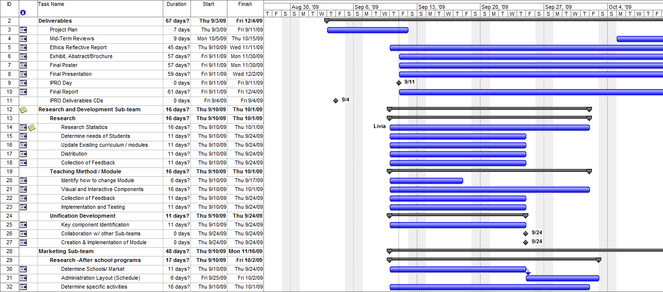
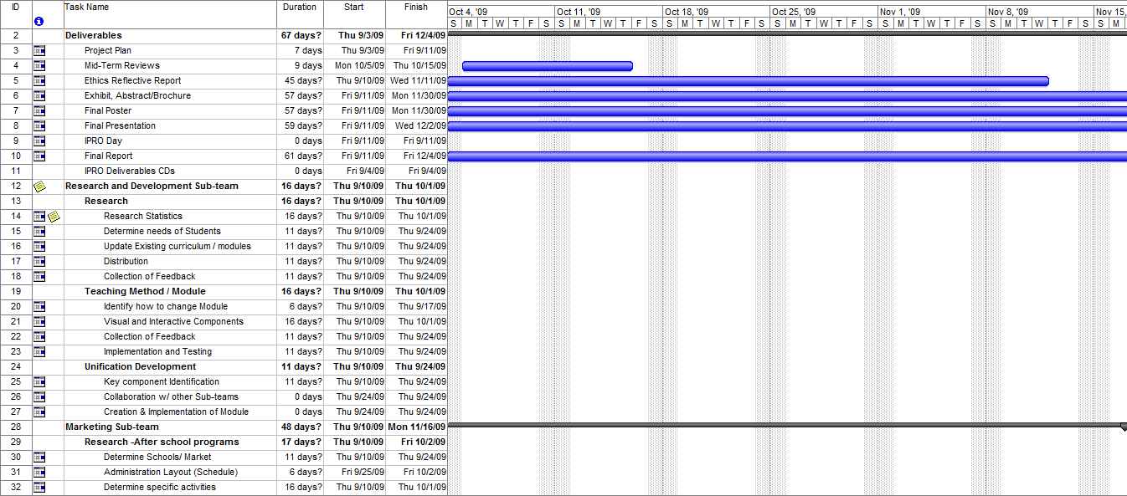
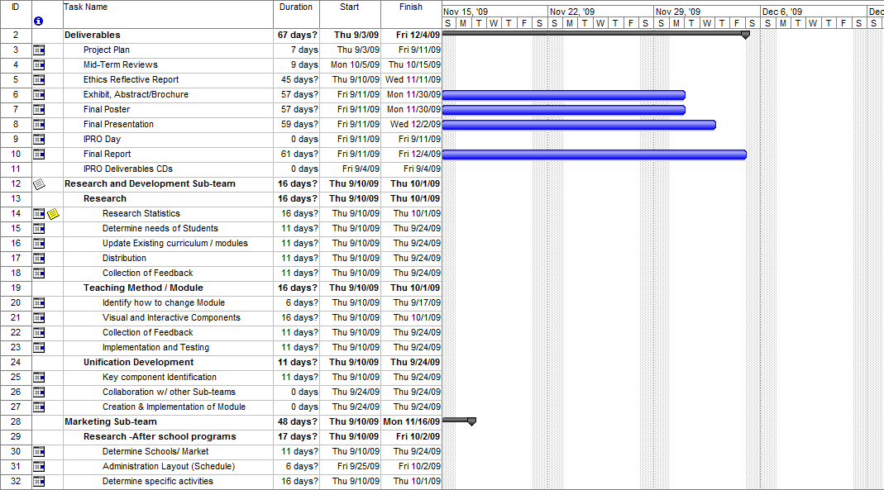
9. Individual Team Member Assignments

Each subteam leader is responsible for facilitating group meetings and insuring that the group stays on task throughout the semester.

- Marketing/Outreach subgroup
- Responsibilities: Take the teaching kits and make them more accessible to a wider audience, through the means of community events, afterschool programs, and through the website Teacher Knowledge Share.
Mayra Vega – Subteam Leader
  - Gina Grande – (Research After School Programs, Website Design, Event Planning)
  - Jorge Chavez – (Planning School Visits, Product Designs, Event Planning)
  - Jason Chin – (Research After School Programs, Product Designs, Event Planning)

- Teaching Kits subgroup
- Responsibilities: Take the current teacher modules created over the past semesters and make the more geared towards high school students, through the means of adding in-class experiments, visual aids, and new creative means of presenting the information in an unbiased manor.
Micheal Tyler – Subteam Leader
  - Livia Lay – (Creating and Update Modules)
  - Jennifer Randle – (Research Statistics, Record Teacher Feedback)
  - Andrew Weiner – (Teacher Liaison and Distributor of Modules)

- Zero Energy House Module subgroup
- Responsibilities: Create a new teaching module that will educate high schools students in how a home can function using zero energy, through the means of subject research, creating a teaching lesson, and presenting the kit to an audience for feedback.
Ross Johnson – Subteam Leader
  - Declain – (Teacher’s script, New Module analysis)
  - Greg Zajac – (Creation of New Module presentation, New Module analysis)
  - Nam Nguyen – (Creation of New Module presentation, New Module analysis)
  - Patrick Olechno – (Creation of New Module presentation, New Module analysis)

- Designation Roles:

Meeting roles:
- Minute Taker: Jason Chin
- Agenda Maker: Subteam Leaders (Rotation)
- Time Keeper: Ross Johnson

Status Roles:

- Master Schedule maker: Micheal Tyler
- iGroups Administrator: Gregory Zajac
- Documentation Collector: Rotating role throughout group

