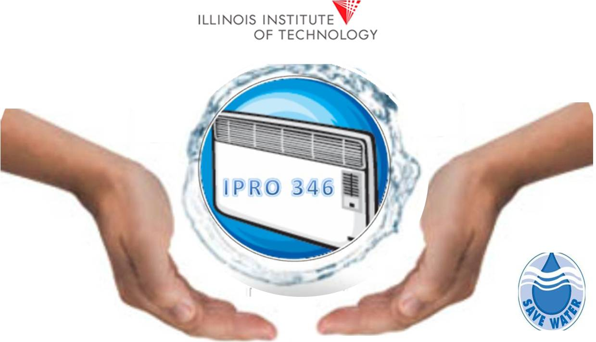

**IPRO 346, Summer 2011**

**Illinois Institute of Technology**

**6/17/2011**

Harvesting & Beneficial Use of Condensate from Air Conditioning Systems



Project Sponsor: Pentair Inc.

**Project Supervisor: Phil Lewis**

**Raksha Rajagopalan Mansi Patel Ester Romo-Ortiz Anthony Ruth**

**Narayan Natarajan Joshua Kenward Cheng Li Rene Tapia**

Table of Contents

Abstract 3

I. Team Charter 4

1. Team Information 4

2. Team member strengths, needs and expectations 5

3. Team Identity 6

4. Team Purpose and Objective 7

Team Purpose 7

Team Objective 7

5. Background 7

6. Team Value Statement 9

Desired Behaviors 9

Conflict Resolution 9

II. Project Methodology 10

1. Work Breakdown structure 10

Problem Solving Process 10

Team Structure 11

Gantt Chart 12

2. Expected Results 13

3. Project Budget 14

4. Designation of Roles 15

III. Reference 16

# Abstract

In an age where sustainability and “going green” have reached an all time high in both the media, and in politics, new initiatives are being explored more than ever before. Many of these initiatives would require drastic changes both in the way corporations do business, and in the way average citizens live their lives. However, there are initiatives which require very little change in lifestyle and business practice, and potentially represent great savings to those who choose to implement them. Like its predecessors, IPRO 346 aims to raise public awareness of the recycling and reuse of condensate produced by air-conditioning systems. This condensate is a byproduct of all AC units, and is currently sent straight to the sewer. Studies conducted by previous IPROs have not only indicated great potential for this initiative, but have also shown a great deal of public interest. Unfortunately, they have also revealed government policies and city codes which greatly restrict the use of this abundant resource. The aim of IPRO 346 is to work towards a change in these policies through the demonstration of a viable system. Members of the team equipped with a model of the systems we propose will meet with public officials, and others interested in the system, demonstrating its potential in hopes of getting policies in place which would allow such a system to be implemented. The IPRO has two main objectives: the development of a prototype and model for demonstration, and the marketing of the idea through the use of both social networks, and presentations to anyone interested. It is the aim of this team, that the accomplishment of these goals will result in both public demand for AC condensate recycling systems, and public policies which allow their use.

# Team Charter

## Team Information

|  |  |  |
| --- | --- | --- |
| Name | Major | Email |
| [Kenward, Joshua](http://igroups.iit.edu/viewprofile.php?uID=6417) | Information Technology and Management | jkenward@iit.edu |
| [Li, Cheng](http://igroups.iit.edu/viewprofile.php?uID=3207) | Applied Math | licheng@iit.edu |
| [Natarajan, Narayan](http://igroups.iit.edu/viewprofile.php?uID=6419) | Aerospace & Mechanical Engineering | nnataraj@iit.edu |
| [Patel, Mansi](http://igroups.iit.edu/viewprofile.php?uID=6193) | Molecular Biochemistry and Biophysics | mpatel67@iit.edu |
| [Rajagopalan, Raksha](http://igroups.iit.edu/viewprofile.php?uID=6319) | Chemical Engineering | rrajago6@iit.edu |
| [Romo-Ortiz, Esther](http://igroups.iit.edu/viewprofile.php?uID=6090) | Psychology | eromoort@iit.edu |
| [Ruth, Anthony](http://igroups.iit.edu/viewprofile.php?uID=6420) | Physics | aruth@iit.edu |
| [Tapia, Rene](http://igroups.iit.edu/viewprofile.php?uID=6421) | Information Technology and Management | rtapia@iit.edu |

|  |  |  |  |  |
| --- | --- | --- | --- | --- |
| Name | Major | What are your Strengths? | What are your expectations of this IPRO? | How many hours a week are you willing to put in for the IPRO? |
| Anthony Ruth | Physics | Calculations, programming, building | To make the water clean enough to drink | 2-4 Hours |
| Cheng Li | Applied Mathematics | Basic Statistics, basic Psychology principles | To make good progress towards a goal we as a group agree upon. | 4-6 Hours |
| Esther Romo-Ortiz | Psychology | a background in social psychology (how to change attitude in people) | To accomplish the our objectives | As many as necessary! |
| Josh Kenward | Information Technology and Management | Microsoft Office, basic C++ and Java, General Computer Networking Skills, Good with Powertools, Good at Giving Presentations, Etc. | I expect to accomplish our objectives (yet to be defined) in a timely manner. I'd like to see us actually implement a system somewhere. | Depends on what is needed |
| Mansi Patel | Molecular Biochemistry and Biophysics | MS office; Research skills; Math and problem-solving skills;Biology, Chemistry, Molecular Biology, Biochemistry,Biophysics and other related disciplines; creativity;organizational,leadership and communication skills, | To be able to achieve the goals we set for this semester, to be able to take this IPRO to a completely new level, incorporate the project idea within people and government and start them to think differently, have fun and create a bond within the team members to be able to increase the efficiency. | 4-6 hours |
| Narayan Natarajan | Aerospace & Mechanical Engineering | Mechanical Constructions and innovations and professional presentation& writing skills and profound in computer usage. | I would like to see this IPRO make a change at some level towards the actual implementation and usage of air conditioning condensate in real life scenario. | As Many as necessary |
| Raksha Rajagopalan | Chemical Engineering | MS Office, Excel , Publisher etc. Leadership skills, Chemistry Laboratory Skills. Research skills. Good at making presentations, giving presentations. Good at communication, Creativity. | To be able to take this IPRO to the next level and make a change from the previous two IPROs. I think we should try achieving all our goals in the given time frame. We should be able to contact government officials, and also maybe try implementing this idea on our campus. | As many as necessary! |
| Rene Tapia | Information Technology and Management | Programming, Hardware, Databases, Business, IT, Communication. | To succeed in making this IPRO a success by achieving the goals we set for ourselves. | As many as needed, but about 5-7 hours outside of class time. |

## Team member strengths, needs and expectations

## Team Identity

Team name:  **IIT SAVES WATER**

Logo:



## Team Purpose and Objective

### Team Purpose

The IPRO Team of Summer 2011 will advance the prior work by focusing upon building public awareness and working to change public policy. The Team will utilize social media promotional strategies/messages and implementation. The Team will also identify the practical and political barriers to main stream harvesting of condensate and develop action plans to overcome the barriers. The two activities of the Team will be to build public enthusiasm for condensate harvesting via social media and secondly to summarize all IPRO condensate efforts into a presentation with collateral materials and share it with organizations that have outreach missions of sustainability and conservation.

### Team Objective

* Build public awareness
  + Social Networking i.e. Facebook and Twitter
* Alter public policy
  + Attend CMAP, Chicago Department of Environment and Illinois Plumbing Inspectors Association meetings.
* Build and set up a prototype condensate collection system for the continuous irrigation of a select garden on campus.
* Build scale model to demonstrate usage at various meetings and events

## Background

Sustainability is the challenge of our times. One of the purposes of IPRO 346 is the advancement of knowledge for applied practical solutions to the challenges of sustainability. The harvesting of condensate is one of the many ideas that promote sustainability. Pentair, a company specialized in providing water solutions, is interested in the technology to harvest the condensate from A/C in buildings.

Condensation is the process by which water vapor becomes a liquid (condensate). Cooling systems rely on evaporator coils which refrigerant fluid changes from liquid to vapor, cooling the coils in the process. Air blowing past the coils cools off as it goes by, and moisture from the air condensates on the coils. Condensate drains carry away the water, usually to the sewer. Instead of wasting it, the water could be harvested for reuse.

In identifying alternative sources of water, one of the first considerations is what those sources will be used for. Potable water, which can be used for drinking, cooking and bathing, among other uses, must meet a high level of purity and safety. Non-potable water is less pure but when handled properly, it can be fine for landscaping irrigation, makeup water for cooling towers, and toilet flushing. Many alternative water sources are suited for non-potable uses, like air conditioning condensate. If we could provide separate plumbing in and around buildings for potable and non-potable water, it opens up significant new options for water supply (1). One of the biggest challenges facing the use of water from condensate is regulations. Most states do not permit separate collection and use of this water, though severe droughts have helped to ease those restrictions in some regions. For example Arizona State University has created a system for water capture: water from the Bio-design Institute’s air-conditioning system is harvested in a 5,000-gallon cistern for landscape irrigation. This provides enough captured water to eliminate the use of tap water for irrigation (2). Also the University of Texas in Austin has had a program for water recovery since 1980s. This program has recycled more than 1.3 billion gallons. The water is used to offset evaporation in their cooling towers (3).

In large commercial buildings, condensate recovery often produces enough water to supply all the landscape irrigation needs. Also air conditioning condensate harvesting is most practical in climates with high humidity like Chicago and condensate recovery is especially attractive in facilities like shopping centers or office buildings (1). A 10,000 square foot office building can produce more than 15,000 gallons of condensate water per year (4). The benefits of the use of condensate are clear; a single lawn sprinkler sprays approximately five gallons of water per minute at a medium flow rate or 10 gallons per minute at a high flow rate. There is saving in water, energy and money (5).

Some ethical concerns that are possible: while air conditioner condensate is inherently pure, as it is essentially distilled water, there is a potential for contamination, especially if the water sits in a warm environment. Also the water is classified as non-potable, so the uses are for flushing toilets, irrigation and makeup for water in cooling towers. The water should never be used for human consumption as it may contain heavy metal from contact with the cooling coils and other HVAC equipment. The lack of minerals in the water also makes it corrosive to most metals, especially steel and iron. The water’s low mineral quality and lack of sanitizers (chlorine, chloramines, etc.) makes it excellent for the purposes of irrigation (4).

## Team Value Statement

### Desired Behaviors

* The use of our best abilities, skills and interests towards achieving the above stated objective.
* Being open minded towards discussions and debates for a solid output
* Being respectful of others ideas
* Uphold professional attitude and methodologies at all times of the project
* Honest and ethical input towards the project objectives.

### Conflict Resolution

Thomas and Kilmann in 1976 suggested a conflict resolution that the IPRO will follow during the course of the project (6). They suggested five basic ways of conflict resolution as stated below:

* Accommodation – surrender one's own needs and wishes to accommodate the other party.
* Avoidance – avoid or postpone conflict by ignoring it, changing the subject, etc.
* Collaboration – work together to find a mutually beneficial solution.
* Compromise – bring the problem into the open and have the third person present aiming towards a compromise.
* Competition – assert one's viewpoint at the potential expense of another.

# Project Methodology

## Work Breakdown structure

## Problem Solving Process:

## The project that our team has decided to accomplish in this summer IPRO can be broken down into a few different smaller projects. These smaller projects will all come together in the end to accomplish the overall goals our team has set out. The smaller projects consist of Public Awareness, full size model, and recognition towards change in public policy.

**Create Public Awareness:**

Maintain social media sites by updating as project moves forward and milestones are reached

Create Twitter and Face-book Media Web-Pages

Add data, pictures, and results to social media pages.

## 

Accomplish goals by having numerous followers and fans as possible.

Present social media sites to governmental and environmental officials.

## Full Size Model:

Create full size model to present to government and environmental entities.

Implement prototype in CAD 3-D software to create full size model

Decide on prototype for presenting ideas that the group wants to implement

Meet and display model to official to represent our ideas and views.

## Full Size Model:

Present Models and Data to officials along with benefits and usage.

Set up meetings and hearing with officials and Dean at IIT.

Reach out to government and environmental entities for meetings and resources

Make a breach in having officials support our ideas and put an effort in trying to achieve a change in plumbing code.

Make clear that we need plumbing code modified in order to conserve water.

## Team Structure

Since we are working on multiple projects at a time, our team decided to split into three different teams. The teams consist of the following:

* Social Media Team
  + Joshua Kenward – Team Lead
  + Mansi Patel
  + Rene Tapia
  + Raksha Rajagopalan
  + Cheng Li
* Marketing Team
  + Raksha Rajagopalan - Team Lead
  + Cheng Li
  + Mansi Patel
  + Esther Romo
  + Narayan Natarajan
  + Rene Tapia
* Prototype Team.
  + Narayan Natarajan – Team Lead
  + Anthony Ruth
  + Joshua Kenward
  + Esther Romo

## 

## Gantt Chart

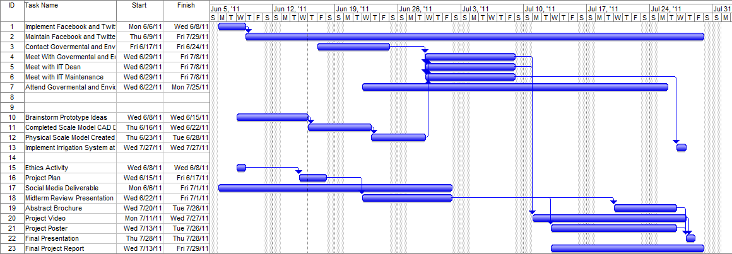

## Expected Results

One of our main goals is to spread the word, let more people know about the facts of condensate from HVAC units, as well as being informed of several ways to utilize this knowledge and use it in different ways. Thus, we expect to accomplish the following:

* Set up several social networking accounts to allow the general public to follow the progress and updates of this project. Specifically, a Twitter account will the running, with a brief description of our goals, and updates will be made public with every step of progress we make. A Facebook page will also be made to have more information readily available to whoever is interested, and feedback from the public can also be received through the same website.
* A scaled 3D model of a commercial building and a HVAC condensate harvesting and re-use system will be produced. This model will be able to demonstrate how the condensate produced through a standard HVAC air-conditioning system can be used within and around the building.
* Contact will be made with local organizations possibly interested in this project, and our ideas and accomplishments will be presented in front of related functions of the city of Chicago, as to persuade for further involvement of the city, and a possible change in the Chicago plumbing code.

Another goal is to have a physical system running, demonstrating the practicality of the project in real life. We expect to achieve the following:

* Through the results of the previous two IPROs and further testing, confirm the safe usage of the condensate.
* Negotiate with relevant departments of IIT to be able to install several parts to an HVAC unit of a building in order to harvest the condensate.
* Design and install a prototype of a system to the same building, which will then in turn use part of the condensate to flush a toilet unit, and the rest of the condensate will be used to water a select area of green on campus, replace the regular irrigation system of said area.

## Project Budget

|  |  |  |
| --- | --- | --- |
| Activity | Cost | Description |
| Transportation for meetings | $ 275 | 2.5 * 4 * 9 = $ 90 CTA charges to get to downtown offices (CMAP).  5 Metra 10-ride passes * $37 = $ 185 to get to offices in the suburbs. |
| Printing | $ 150 | Printing costs for IPRO deliverables/ posters/brochures for IPRO day and for presentations at meetings and with the government. |
| Model supplies | $ 100 | Items like paint, decorations, bottles, toilet for scale model. |
| Food | $ 200 | Lunch for 8 students * 2 meetings each * $12/student. |
| IIT water recover system | $ 500 | Installation and working of a real time model at IIT and buying supplies for it like pipes, sprinklers, reservoir, plumbing supplies etc. |
| Attendance fee for Chicago public meetings | $200 | Registration fees for various city meetings and discussions. |
| TOTAL | **$1425** |  |

## Designation of Roles

1. **Minute Taker : Mansi Patel**

* Responsible for taking minutes during team meetings.
* Keeps a note of any tasks assigned or updates.
* Sends out emails within 2 days of the meetings regarding the tasks and minutes.

1. **Agenda Maker : Raksha Rajagopalan**

* Responsible for making weekly agendas comprising of what needs to be accomplished during the week and in the meetings.
* Sends out the agendas to everyone a night before the meetings.

1. **Time Keeper : Narayan Natarajan**

* Responsible for ensuring that the IPRO deliverables are completed and submitted on time.
* Makes sure that the meetings run according to the agenda.

1. **iGroups Moderator : Cheng Li**

* Responsible for uploading the IPRO deliverables on iGroups.
* Updates all the important information discussed in class on iGroups.

# Reference

(1) http://www.buildinggreen.com/auth/article.cfm/2008/4/29/Alternative-Water-Sources-

Supply-Side-Solutions-for-Green-Buildings/

(2) http://sustainability.asu.edu/index.php

(3) http://www.esi.utexas.edu/component/content/article/13/97-water-at-esi

(4) http://www.allianceforwaterefficiency.org/Condensate_Water_Introduction.aspx

(5) http://melbourneflorida.org/

(6) http://businessmediationnow.com/about_us_1.html