|  |  |  |  |  |  |
| --- | --- | --- | --- | --- | --- |
| |  | | --- | |  | |  | |  | |  | |  | |
|  |
| IPRO 320 – Project Plan  **PB OUR SPACE–  A Parsons Brinckerhoff Project** |
| Illinois Institute of Technology  Summer 2011 |

Table of Contents

I. Team Charter 1

1. Team Information 1

2. Team Purpose and Objectives 4

3. Background 5

4. Team Values Statement 6

Desired Behavior 6

Project Conflicts 7

II. Project Methodology 8

1. Work Breakdown Structure 8

The Process 8

Team Structure 9

Gantt Chart 10

2. Expected Results 11

3. Project Budget 12

4. Designations of Roles 13

# Team Charter

## 1. Team Information

### PB OUR SPACE

*“Giving Everyone a Voice”*

**IPRO Instructor –** Laura Batson

**Roster and Personal Qualities:**

|  |  |
| --- | --- |
| **Vince Bell ­**  Business­  vbell@iit.edu ­ | **Individual Strengths:**  Identifying financial and societal costs and benefits for projects, and examining major conceptual aspects of a problem or situation  **Skills to Develop:**  Organizational, leadership and research skills  **Expectations for the Project:**  To storyboard this project to decrease the amount of planning and workload for future students continuing this IPRO |
| **Matthew Kavicky ­**  Applied Mathematics ­  mkavicky@iit.edu ­ | **Individual Strengths:**  Working well in team situations—particularly where communication is open and teammates can bounce ideas off of each other, dedication, organization and hardworking  **Skills to Develop:**  To further improve my interaction skills with classmates and also with the company, and gain additional experience working with technical documents, flowcharts, etc.  **Expectations for the Project:**  To achieve what the company expects and at a satisfactory level, and to gain valuable experience throughout the process |
| **Taimoor Khan ­**  Mechanical Engineering­ ­  tkhan6@iit.edu ­ | **Individual Strengths:**  Team management, verbal, problem-solving, analytical skills Proficient in Microsoft Office  **Skills to Develop:**  Programming  **Expectations for the Project:**  Learn about Parsons Brinkerhoff. |
| **Ciaran Kohli-Lynch ­**  Mechanical Engineering­ ­  ckohlily@iit.edu ­ | **Individual Strengths:**  Researching thoroughly from creative, new perspectives.  Writing is of a high standard, and I am willing to work hard when given objectives and perform well under pressure.  **Skills to Develop:**  Organizational skills and being more vocal in group settings  **Expectations for the Project:**  I anticipate that this project will provide an interesting and thought-provoking look at the world of work in a field, which I know very little about. The research-based nature of this project is appealing, as it will develop skills, which are useful in a large range of different career paths. |
| **Nick Leevathana ­**  Mechanical Engineering­ ­  nleevath@iit.edu ­ | **Individual Strengths:**  Problem solving, analytical/team skills. Proficient in MS Office and familiar with Solidworks  **Skills to Develop:**  Coding and Programming. Improving business management and project planning skills  **Expectations for the Project:**  To gain work/project experience while enhancing team building skills; to build future contacts and references |
| **Phillip McBride ­**  Architecture ­  pmcbrid@iit.edu ­ | **Individual Strengths:**  Designing and finding creative solutions for problems, and expanding on others’ ideas to create a better-finished product.  **Skills to Develop:**  To be better acquainted with various disabilities so that I may someday find architectural solutions to making their life simpler.  **Expectations for the Project:**  To storyboard on making a mobile application and for our group to precisely research all avenues of completing the project |
| **Hao Nguyen ­**  Mechanical Engineering­ ­  hnguye9@iit.edu ­ | **Individual Strengths:**  Problem-solving skills, mathematical, and good collaborator  **Skills to Develop:**  Creativity, decisiveness, confidence, project management  **Expectations for the Project:**  To meet the company’s expectations, develop team relations |
| **Abigail Vargas ­**  Civil Engineering ­  avargas@iit.edu ­ | **Individual Strengths:**  Skills of MS Office, design experience in AutoCAD, good team/project management skills, analytical problem solving, creative  **Skills to Develop:**  Public speaking, community research, exposure to team building exercises  **Expectations for the Project:**  Strengthening project management skills, meet PB’s needs, become more aware of the community influence with building planning, develop contacts and future references |
| **David Wilkinson ­**  Architectural Engineering­ ­  dwilkin1@iit.edu ­ | **Individual Strengths:**  Researching and visual presentational skills  **Skills to Develop:**  Public and group speaking  **Expectations for the Project:**  To improve my ability in participating and communicating teams |

## 2. Team Purpose and Objectives

Leveraging the existing technologies currently available in the marketplace enables the IPRO to create a team-networking solution that reaches more stakeholders and provides a richer, more enhanced venue for project collaboration. The solution devised by the IPRO must be easily accessible and interactive allowing for data capture, storage, retrieval and viewing amongst an array of end-user devices.

To provide a successful solution, this IPRO will storyboard the concept over the summer, prototype the concept during the fall and execute usability studies the prototype during the spring semesters.

Summer Semester IPRO Activities:

* Categorize stakeholders into archetypes (groups who do similar tasks)
* Determine different scenarios for each type of stakeholder
* Consider stakeholder disabilities, languages, logistics and other diversities
* Research platform for “PB Place” and the devices to support collaboration with stakeholders
* Research “data governance” of the stakeholders with Parsons Brinkerhoff ( including login and registration capabilities)
* Create storyboard of “PB Space” including login and registration
* Create storyboards of archetypes of stakeholders and scenarios of stakeholders using “PB Space”
* Review ethical issues that impact this type of social network

Deliverables:

* Formal recommendation report including storyboards
* Storyboard posters for the archetypes and scenarios of stakeholders
* Storyboard login and registration capabilities

Team Structure:

An overall student team leader will lead the team. For the first half of the summer semester, the team will be structured into two groups. The first group will research stakeholder archetypes and scenarios. The second group will research platform and possible devices for “PB Space.” For the second half the summer semester the groups may reorganize. The first group will focus on design of storyboards and IPRO day materials. The second group will focus on the formal report and administrative details.

Fall Semester IPRO Activities:

* Review storyboards from summer semester, research alternatives, and update
* Facilitate surveys and focus groups to discuss the storyboards and solutions
* Revise scenarios and storyboards
* Create a prototype to include:
* Login and registration
* Different module prototypes for each type of scenario
* Update ethical issues that impact this application

Deliverables:

* Report on outcome of surveys and focus groups
* Prototype of the application
* Formal recommendation report for first phase of prototype

## 3. Background

Parsons Brinkerhoff is a an engineering, construction, technical, and management services firm that provides diverse solutions to private industrial customers worldwide, as well as to federal, regional, and local government agencies. Gathering requirements and feedback from each of these stakeholders are imperative, but can be a challenge due to the stakeholders’ diversity and location constraints. This IPRO is being commissioned to find better ways to interact with the stakeholders by leveraging today’s “best of breed” mobile technologies.

Mobile technologies are an increasingly powerful channel for sales, marketing and for the delivery of interactive services to customers. By 2016, the value of the U.S. mobile economy will reach over $427 billion per year. Clearly, mobile applications are becoming the preferred form of communication and collaboration by individuals, consumers and industry. The IPRO is tasked with researching and determining how to develop a mobile-based platform that supports a network and/or community of collaborators on transportation and design projects. Public (e.g. Facebook, MySpace) and Parsons Brinkerhoff’s own social network applications exist and are widely used by staff and stakeholders.

The IPRO project team will build on these systems to create a mobile-based platform (“PB Place”) that allows users to share comments, files, video and other data with common groups. While components of this platform already exist as commercially available products and open source software, there is nonetheless, the challenge of creating a customized solution that accommodates the specific needs of Parsons Brinkerhoff and its stakeholders.

## 4. Team Values Statement

### Desired Behavior

All members will be expected to show up on time for group meetings.

* The goals of Parsons Brinkerhoff take priority; we will make sure to achieve their desired outcomes with satisfaction, going above and beyond their expectations.
* Active participation is mandatory for all members of the team.  This includes voicing opinions and asking questions when they arise, while still being mindful of when other members are speaking.
* Mutual respect among all team members is mandatory.  Members are encouraged to debate possible options to achieve the best quality outcomes, but always do so constructively and respectfully.
* Always keep the team in mind; bring unique skills to the table, and use these to help the group discuss and develop professional results.

### Project Conflicts

We will strive to solve the issues arising in our effort to work on the project as efficiently as possible. A team member encountering an issue with completing a task will first do their best to remedy the situation themselves.

* If unable to solve the issue themselves, the team members will contact the team leader or task leader to inform them of the issue. This can be done using any form of communication.
* If both the team and/or task leader are unable to solve the issue the issue will be brought up at the following team meeting and officially documented on iGroups.
* Once it is determined that this problem will not be able to be solved by the entire team or our advisor, we will document that problem for our final product as an issue the group faced.

# II. Project Methodology

## 1. Work Breakdown Structure

### The Process

Our team will begin solving the problems in our project first by conducting research and gathering research. By gathering research, we will better understand how to address the issues. Once we have more information we will begin developing a strategy for developing a prototype storyboard for our project. The major tasks in completing this process will be:

* Finding or designing a suitable digital database space for Parsons Brinckerhoff’s purposes
* Developing purposeful questions for different archetypes affected by Parsons Brinckerhoff projects
* Developing both a visual and written storyboard of how our design for the PB space will work
* Presenting a final report of our work and process on IPRO day

We will test the solutions by verifying with our advisor and our sponsor, Parsons Brinckerhoff, that what we developed so far will satisfy their desires and goals for the project. We will document in our final report all the steps we took to develop our storyboard prototype. We are fully capable in finishing the goals and tasks that we have set for this project in the time period.

Our team is divided into two sub-teams—research and prototype/communication; however, although divided, they will work interdependently so that the objectives for this project are met.

### Team Structure

**Team Leader**Vince

* Sets the agenda for meetings
* Guides team with task to complete the project

**Research Team**   
Ciaran, Phillip, David, Nick

* Conducts major research

**Prototype/Communication Team**   
Matt, Abbey, Tai

* Communicates with PB to develop a desirable storyboard prototype

**Task Leader**   
Hao

* Updates team members on tasks and new information
* Moderates iGroups

## 

### Gantt Chart

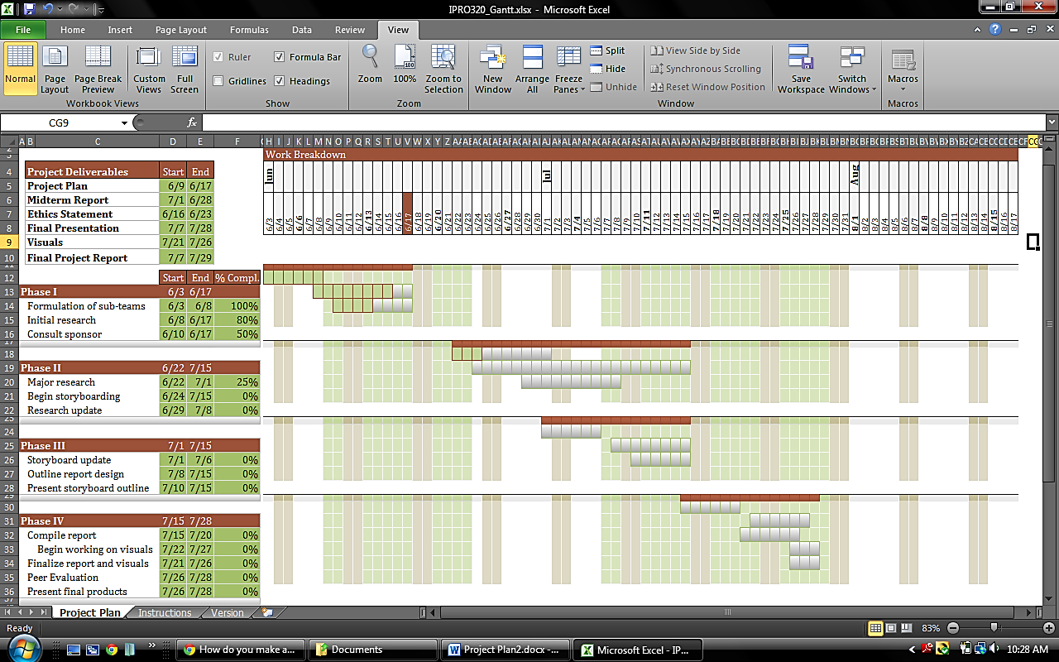

## 2. Expected Results

Since most of the activities are heavily research based, we have broken up the project team into different research categories. The teams will present their gatherings and contribute in finalizing the project.

* The ethics researcher will look into ethical dilemmas involving past Parsons Brinkerhoff’s projects, and define social benefits of our project.
* The Parsons Brinckerhoff researcher will trace back the history of Parsons Brinckerhoff, past relationships, and how the company conducted surveys in the past.
* The construction project researcher will determine the stakeholders and any resistance the project could potentially meet.
* The archetype researcher will research the needs and wants of the archetypes. They will also determine the risk and gains for archetypes from the Parsons Brinkerhoff’s projects.
* The prototype designer will research the past effective surveys and other methods used by Parsons Brinckerhoff. In addition the prototype designer researches new application alternatives and how to bundle the applications. Then, an information architecture and ideas for a PB interface to view the information will be diagramed.
* The Parsons Brinckerhoff communicator will act as a liaison that will manage communication between the group and Parsons Brinckerhoff.
* The report designer will coordinate the design and format of the reports.
* The visual designer will coordinate creating and outlining all visual displays.

Data gathered from research on the archetypes will help develop a prototype, which will provide useful information for Parsons Brinckerhoff. The PB researcher will provide information towards the type of product consumers can expect from Parsons Brinckerhoff. The research provided by the prototype designer will aid in targeting a specific demographic for Parsons Brinckerhoff. The work done by the visual design team will facilitate the structure for the following semesters.

As a result, the deliverables that will be produced are:

* Formal recommendation reports including storyboards
* Storyboard posters for the archetypes and scenarios of stakeholders
* Storyboard login and registration capabilities.

Challenges that can affect the outcome of this project include team chemistry, promptness in meeting deadlines, and the communication between Parsons Brinckerhoff and our group. Once information is collected, the team can then produce storyboards. These storyboards will help in the development of prototyping a mobile application, which will be further analyzed in the future.

## 3. Project Budget

Our budget includes expenses for materials and supplies for IPRO Day. The current budget refers to materials needed for publications and prototype printing of screenshots. In the following semesters there will be expenses regarding finalizing an actual prototype of the application.

IPRO 320 – Estimated Budget

|  |  |
| --- | --- |
| Expense Category | Amount Estimated |
| Materials and Supplies | $ 300 |
| Prototype printing of screenshots |  |
| Publications and Communications | $ 200 |
| Poster and Brochure for IPRO Day |  |
| Other Expenses   Misc. supplies | $ 200 |
|  |  |
| Total | $ 700 |

## 4. Designations of Roles

**Ethics Researcher:** Ciaran and Nick look into the ethical dilemmas involved in implementing our project.

**Parsons Brinckerhoff Researcher:** David and Abbey research the history of Parsons Brinckerhoff

**Construction Project Researcher:** Ciaran determines and defines all stakeholders in the project.

**Archetype Researcher:** Matt and Tai research and define the type of archetypical populations involved in PB projects.

**PB Prototype Researcher:** Phillip researches how the applications work together, database design, and PB interface for the data.

**Protégé Designer:** Matt plans and designs the layout and operations of the PB data space.

**Parsons Brinckerhoff Communicator:** Tai manages communication between PB and group.

**Task Leader /Report Designer:** Hao ensures tasks are assigned to all members, and finalizes the format and design of the reports.

**Team Leader/ Project Milestone Recorder:** Vince keeps the IPRO team up to date by reviewing past accomplishments and setting future goals.

**Visual Designer:** Phillip, Dave and Abbey create the outline and format for all visual displays.

**Budget Analyst:** Tai administers a feasible budget for the project

**Minute Taker/Manage I Groups:** Hao Nguyen will moderate all tasks involving iGroups as well as recording notes for the IPRO team on a weekly basis.